Consider the Possibilities...
6 Most Common Reasons to Start a Mary Kay Business
M   | Money  Would you be interested in a career where you control the amount of money you earn?  Three are several avenues of income and whether you’re looking for an extra $50 a week or a $1000 a month, your earning potential is up to you. | C  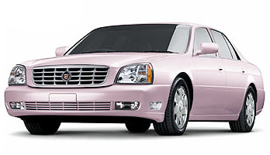 | Cars  When was the last time you earned the use of a career car?  Choose to drive company car or take the cash compensation. The program starts with a Pontiac Vibe or $375 cash, you choose.
R | Recognition  When was the last time your company or your family recognized you for a job well done?  In Mary Kay you are recognized for everything you do. Whether it’s with a diamond ring, a ribbon, or simply with words of praise, it feels good to be appreciated. | A   | Advancement  Have you ever worked very hard for a company and were passed over for a promotion?  In Mary Kay you advance at your own pace and the opportunity for advancement is unlimited.
S  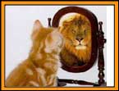 | Self-confidence and Personal Growth  Can you get excited about a career that not only helps you build your income, but also helps you build your self-esteem and self-confidence at the same time?  There are opportunities for you to grow personally as well as professionally and work in a positive environment that encourages personal growth. | B   | Be Your Own Boss  Do you have the flexibility to work the hours you want to work, t be home when your children get out of school, to be, in essence, your own boss?  Imagine having the freedom of being self-employed and the flexibility of working the hours you want to work.

TODAY’S WOMAN
Name: ______________________________________________________________ Date: ___________________________________
- People Oriented
Loves to talk
Motivational
Enthusiastic
Likes recognition
Likes to have fun

- Family Oriented
Loyal
Slow to change
Security Minded
Goes by the rules
Likes Stability

- Detail Oriented
Perfectionist
Critical
Analytical
Doesn’t like change
Consistent

Address: _____________________________________________________________________________________________________
City: __________________________________________ State: ____ Zip: _________ Email: __________________________________
Phone: H (_____) ________________________ W (_____) _________________________ C (______) ___________________________
Current Occupation: _____________________________________________ Consultant’s Name: _________________________________
- Results Oriented
Quick Decision
Power & Authority
Likes Management
Time is Valuable
To the point

Place an “A” in the One Box That Best Describes You and “B” For Your Second Choice
- What do you like most about your present job? ____________________________________________________________
- If you knew you could not fail, would you try Mary Kay now or in the future as…?
❐ Hobby  Part Time Full Time
- To help in your consultant’s training would you consider listening to the fun fast facts of our business, give us feedback and then receive a free gift with no obligation?  YES  NO  MAYBE
- If you were accepted as a consultant what would be your greatest strength? _______________________________________________________
____________________________________________________________________________________________________________________

