Select the Mary Kay Party Tote – Mock Croc!!!!

BE A STAR CONSULTANT!!!

**[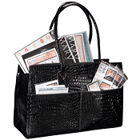](https://mkconnections.b2direct.com/product.aspx?lineid=95&productid=127)**

**OR** - Select the Mary Kay Digital Tablet Case!!!!!!

[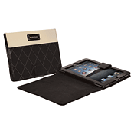](https://mkconnections.b2direct.com/product.aspx?lineid=95&productid=210)

**OR** - Select the Mary Kay Zippered Datebook Cover!!!!!!

[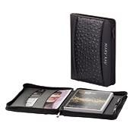](https://mkconnections.b2direct.com/product.aspx?lineid=95&productid=144)

Which prize will YOU choose!! BE A STAR, YOU CAN DO IT!!!!!