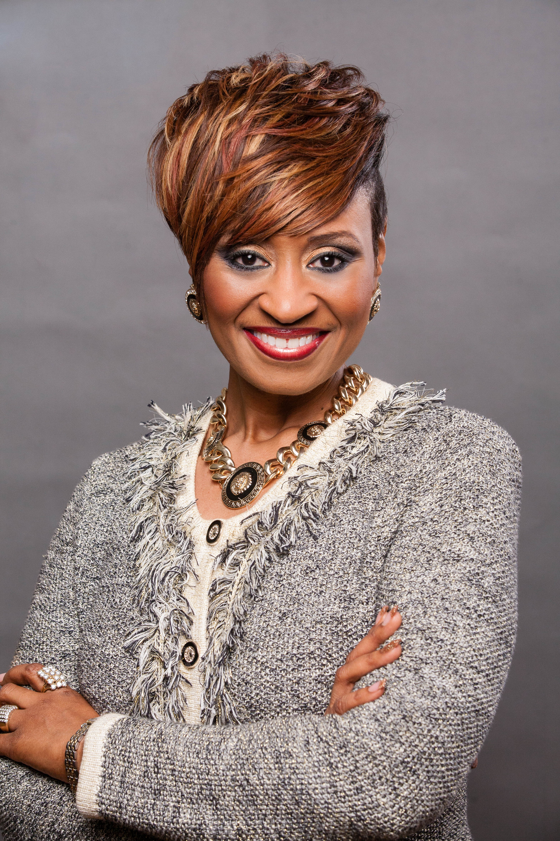
FNSDPATRICE SMITH
This former elementary school teacher and Human Resources Manager began her Mary Kay career in 2004. Within her 1st 6 months she became a Grand Achiever Sales Director earning her 1st Free Career Car!! In her 10 year career with Mary Kay she has earned the use of 7 career cars, 5 of which have been the fluffy Pink Cadillac.
Some of Patrice’s other accomplishments include: Being featured in the March 2011 Applause Magazine, 40 quarter Star Consultant, 17 gold medals, 7 appearances in the Circle of Achievement - $400,000 Circle (2x’s) $450,000 Circle (1x), $500,000 Circle(2x’s) and $550,000 Circle (2x’s), earning 22 stunning carats of diamonds.
7 time Double Star Achiever, 4 time member of the National Court of Sales, and a 4 time member of the National Court of Sharing. In 2008 she led her unit to become the #1 Most Improved Unit in the State of Alabama. Her highest combined MONTHLY income has been in excess of $15,000!!!!!!
Patrice is married to her college sweetheart, L. Spenser Smith and they share 3 amazing children – 19 year old twins Jori Aaliyah and Jamel Alexander, and Jarren Andrew, 15. When asked what is the secret to her success? She says it’s found in Genesis 12:2. The Lord has blessed her and MADE her to be a blessing to countless others.
I present to some and introduce to others FNSD Patrice Moore-Smith!!!

