
It’s Girl Time
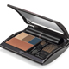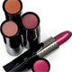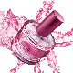

$100 FREE when you party with me!

$25 FREE call me in 24-48 Hours with a guest list of 15 (“I’ll do the work, all I need are names, addresses & phone numbers”)

$25 FREE with $300 or more in sales (outside orders count)

$25 FREE with 5 or more purchasing guests

$25 FREE with 2 future bookings

Bonus $25 Free with at least 10 Facialing guests

