 

**Debbie’s Joyful Giraffes – June Goal $10,000**

***Our Unit is Currently Ranking as the #1 New Unit this seminar year!***

Way to go unit – Our goal is to finish strong & create Cadillac Momentum

*Break a Record in the Diem National Area!*

**My Goal is to help you make $$$$ through Parties – Facials – Team Building**

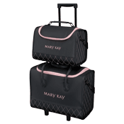



**BONUS:**

June 1 – 15 -- Finish Your Star Consultantship

($1800 wholesale or the next level star if you are already a star)

ALSO WILL RECEIVE the 2 piece Wheeled Tote from MK Connections!!

**When you order: You will receive:**

$250 whls MK Charm Bracelet or a new charm to go on it

$400 whls MK Share the Love Necklace plus the above prize

$600 whls Professional Croc Datebook Cover + Above prizes

$800 whls Professional Croc Party Tote + Above prizes

$1000 whls Gift Certificate to your favorite Massage Therapist/manicurist

+ ALL OF THE ABOVE