

Academy of Glam Color Certification

_______________

(Your name)

Model’s Name Date

1.

2.

3.

4.

5.

6.

7.

8.

9.

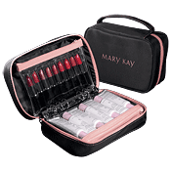

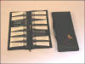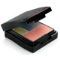

Certification period: Success Events in April!

Tuesday, April 1st

Tuesday, April 8th

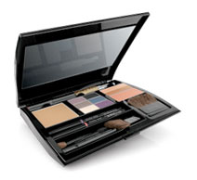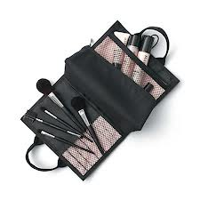 Tuesday, April 15th

Tuesday, April 22nd

Tuesday, April 29th

*Become Color Certified & earn a Free Compact Mini!*

**Bonus – Put your training into action:**

One lucky Consultant will win a **Show N Go Set/Foundation Caddy** in a drawing on 4/29!

(Earn one entry for every guest to TNL and one entry for every outside facial above 5.)

Consultant with the MOST guests to TNL in April will win a **Compact Pro (Min of 4)**!

Work Full Circle to add 1 Qualified New Consultant & earn the **New Brush Collection**!

Academy of Glam Qualifications:

1. You must have a Minimum of **4 qualified guests\*** during the Certification period. Your guests will receive model makeovers specific to that week’s special focus (i.e. eyes, lips, foundation, etc.)

2. YOU must be present at ALL TNL Academy of Glam events with or without a guest. Consultant training each week will be highly specific training on that week’s topic. If you miss a week your certification will not be complete!

3. Pay special attention to emails before each event for any specific supplies you

will need for your guests that may be different from regular TNL makeovers.

*Qualified Guests must be **first-time** guests over the age of 18 without an existing consultant.

How to ask your guests to be a part of your Color Certification

Hi Susan, this is ____ with Mary Kay Cosmetics, do you have a quick minute? I am so excited!

Have you ever wondered what glamour colors would be just right for you? I am getting

Certified with Mary Kay, and I will be color profiling some of my favorite clients (friends, co

workers). What this means is we’ll be taking into account your hair color, your eye color, skin

tone, etc. and develop a glamour look that you will be proud of every day because it’s all

YOURS!! What do you say? Would you like to try your own color profile and help me get Color

Certified? Great! What’s best for you, this Tuesday evening or next?

How to ask someone you just met to be a part of your Certification

Excuse me, have you ever been a Mary Kay model? No? I’m a Beauty Consultant with Mary

Kay and we are looking for face models for our Color Certification class this Tuesday and I

couldn’t help but notice your eyes (or whatever you noticed) - I would love to feature you at our

class. What do you say? Would you like to try your own color profile and help me get Color

Certified? Great! What’s best for you, this Tuesday evening or next?

Please bring the following supplies for EACH MODEL to all Color Certification Events

• CLEAN Face Case (packed with tray, facial cloth, cotton balls, and Q-Tips and applicators)

• Color Card

• Customer Profile

• Sales Ticket

• Beauty Book

• Filled Travel Roll-Up Bag to SELL, SELL, SELL!!!!