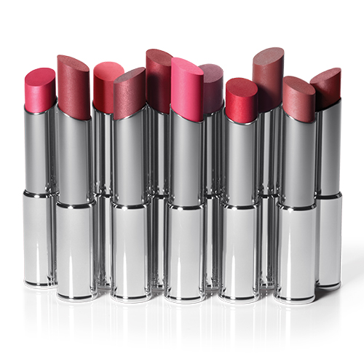The Lipstick Challenge

May 13-June 15, 2014

Date___/___/___

Name_____________________

39

26

13

|  |  |  |
| --- | --- | --- |
| Date of Sale | Date of Sale | Date of Sale |
|  |  |  |
|  |  |  |
|  |  |  |
|  |  |  |
|  |  |  |
|  |  |  |
|  |  |  |
|  |  |  |
|  |  |  |
|  |  |  |
|  |  |  |
|  |  |  |
|  |  |  |
|  |  |  |
|  |  |  |

Sell 13 lipsticks/lip glosses and your name goes in the drawing for a prize,   
Sell 26 and your name goes in twice, sell 39 and you are guaranteed a PRIZE!