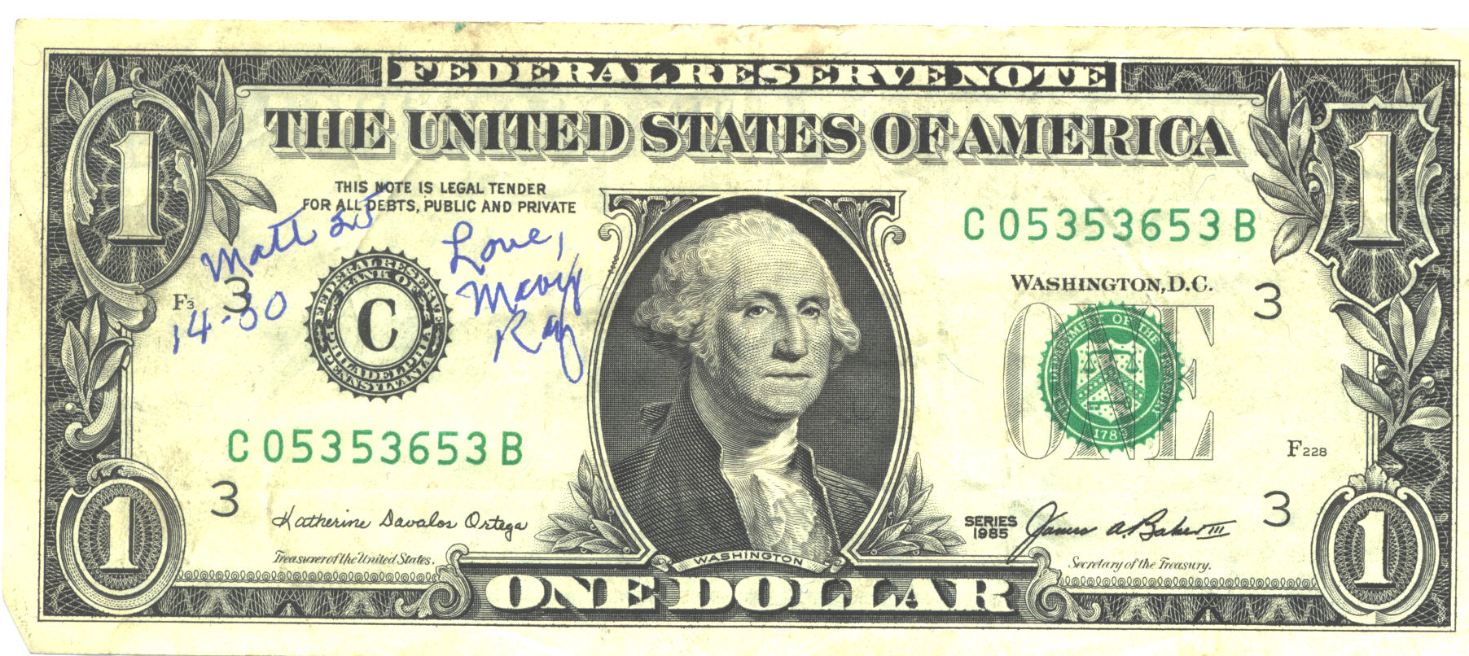
24 HOUR CHALLENGE

 | Name | Phone Number | Total
1
2
3
4
5
6
7
8
9
10
11
12
13
14
15
16
You can do it!
17
18
19
20
21
22
23
24
Fill out the outside order form with color choices & or other products.
Write your name & phone number on one line for each $25.00 purchase.
PLUS, everyone who makes a $25.00+ purchase will receive a $5.00 credit towards a future purchase at their makeover. Schedule your makeover today to be held with in 2 weeks with 2 or more friends and your credit turns into $50!
When all 24 lines are filled a drawing will be held for a $50.00 Shopping Spree!
One lucky winner!

