

Tresaugue S.T.A.R.S. Unit

***WELCOME!***

*Congratulations on your decision to become a Mary Kay Independent Beauty Consultant. I truly believe the reason for our success now and in the future, can be traced to one common factor: quality people like you! Welcome to our fabulous unit!*

*Our unit name is Tresaugue S.T.A.R.S. Unit (Soaring to the Top And Reaching for the Stars). The name represents all that is possible with this opportunity if you are willing to work for yourself in a way you would work for someone else. Our mission is to help make dreams a reality and miracles come true one woman at a time. Our unit number is PD93. We are part of Ruby Seminar and are in Somer Fortenberry’s F.A.I.T.H. National area!*

*I love this business because you never stop learning, and there are always opportunities to grow. As a new consultant, I strongly urge you to start scheduling and holding your first appointments as son as you receive your Starter Kit, because what you lack in experience you will make up for in enthusiasm! Although, you’ll have the opportunity to take advantage of continuous education in your Mary Kay business, activity will provide your greatest sense of learning. Mary Kay herself often said, “you can do everything right with the wrong attitude and fail to succeed, but you can do everything wrong with the right attitude and succeed beyond your dreams!” The first few weeks of your Mary Kay business can really set the pace for your future!*

*I am so excited for you! I care about your future and am committed to helping you succeed. You’ll want to try all the products, read over this packet, and start working on your contact list, which is enclosed. As always, I will match my time 100% with your effort! Be patient with yourself and just take it one step at a time. We’ll move at your pace! Have a great start!*

*Cheering you on as you begin your incredible journey!*

*Love and Endless Belief in You,*

***Chandra Tresaugue***

*Your Mary Kay Sales Director*

Contact Information

*Address:*

*3004 Hoover Ave SE*

*Port Orchard, WA 98366*

*Phone: 360-990-1721*

*Email: tresaugue@marykay.com*



##### What To Do in My First Month as a New Consultant

**WEEK1**

DAY 1

* Download the New Consultant Training Packet at [www.somornsd.com](http://www.somornsd.com) under Training/New Consultant Tab.
* Call and Listen to “Inventory Information” by NSD, Somer Fortenberry 641-715-3800 (19871#-Ext 1)
* Watch Inventory Video at [www.somernsd.com-New](http://www.somernsd.com-New/) Consultant Page

DAY 2

* Go through New Consultant Training Packet/Ask Questions
* Call and Listen New Consultant Orientation by NSD, Somer Fortenberry 641-715-3800 (19871#­

Ext. 2)

DAY 3

* Contact *Chandra with any questions 360-990-1721*

DAY4

* Set up the following:
  + •Mary Kay InTouch Log-in:[www.](http://www/)marykayintouch..com
  + Personal MK Website (Only $25 1st year and $50 every year after that)
  + Personal MK Email Address (forwards to your current email)
  + Order your 50 free business cards
  + Set up a separate checking account for your MK (Personal NOT business)

DAY 5

* Schedule Debut-we need to look at dates when you have some time
* Make a list of at least 75 women, put a * by the ones you think would be good at MK. Mail out debut invites..
* Attend your weekly Success Meeting!

WEEK2

* Listen to the first 2 New Consultant Training Calls-641-715-3800 (49429#) ·Welcome. Ext 2 and Tax and Money Management Ext 3 Call Chandra with Questions
* Hold Your first Facial
* Get at least 2 people to Listen for a Lip-gloss or bring to Meeting 559-726-1099 Access Code 273196# then # again
* Attend your weekly Success Meeting!

WEEK 3

* Listen to New Consultant Training Calls 3 & 4 641-715-3800 (49429#). Skin Care Class How To Ext 4

(Next please Watch video at <http://www.rachelnaylor.com?page_id=377>) and Team Building Exl5)

* Work on Power Start
* Attend Your Weekly Success Meeting-Bring guest and/or have them listen to the Lip-gloss hotline

WEEK4

* Listen to new consultant training calls 5 & 6 641-715-3800 (49429#) – Image and Career path Ext 6 and whit id possible in the first year Ext 7
* Attend Your Weekly Success Meeting-Bring guest and/or have them listen to lip-gloss hotline

Attend New Consultant Boot Camp at the Success Center the first Thursday of the Month at 7pm!

NEW CONSULTANT TRAINING

##### New Consultant Training-Calls



Phone #: (641) 715-3800 - Access Code: 49429#

*After entering access code you will enter the extension for the training*

*Session you want to hear!*

1. New Consultant Welcome-Premier Club Director, Dana Andrews
2. Tax & Money Management-Senior Director, Teresa Martin-Sykola
3. Skin Care Class-Cadillac Director, Rachel Naylor
4. Team Building-National Sales Director, Somer B.Fortenberry
5. Image and the Career Path-Future Exec. Cadillac Director, Kimberly Perkins
6. What’s Possible In Your First Year In Business?!-Future Executive Cadillac

Director, Lesley Speas

##### New Consultant Training-Boot Camp Training

1st Thursday of Every Month @7:00pm

Location: Success Center, 9481 Silverdale Way, Ste. 200, Silverdale WA

*Come learn the basics of the Mary Kay Business! Imperative training for every New Consultant!*

Silver Scholars Program

*The Silver Scholars Program is available on marykayintouch.com. The program*

*For New Consultants was designed to guide you through the basics of owning your*

*Own MK Business. It trains on the following topics: Opening your Starter Kit, Time*

*Management, Working with Customers and Hostesses, Selling and Inventory,*

*Overcoming Objections, Goal Setting, Getting Organized, Dialogues, and more!*

*You can complete all the Lessons around your schedule! Also, there are other*

*lessons as you progress in your Mary Kay Career.*

##### Listen for a Lip Gloss Team Building Conference Call

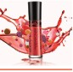

*Have your potential new team members call in anytime to our Listen for a Lip*

*Gloss Hotline! They will hear facts about the MK Opportunity. Guests who follow up with your director within 24 hours of the call will receive a FREE lip gloss from your Director! (Color Choice by Director)*

559-726-1099 Access Code 273196# then # again

##### Weekly Success Meetings

*Meetings are not mandatory b111 are a vital part of your success!*



*Those who show up go up!*

*Kitsap County and surrounding areas: Mondays at 630pm @ Success*

*Center, 9481 Silverdale Way Ste. 200, Silverdale, WA Bring guests along with your WAS at 620pm*

Cost FREE! Purchase raffle tickets to help cover the cost of running

The studio, you can win prizes for the nightly raffles and quarterly

Raffles!

Business Debut Checklist

*Your Business Debut is the best way for me to support you as you begin your business! I am here to support you in every way and will match my time with your efforts!*

Schedule your business debut within your 1st 2-3 weeks of your business! You will to have your inventory in stock before your Business Debut.

Invite all people on your Contact List. (You can expect 10 to attend if you invite 50, with

proper follow-up).

Send out a minimum of 50 Business Debut Invitations (send one to your Director).

Follow up with EVERYONE you invited 24-48 hours before your Debut. Sending postcards alone will not be effective. After you have mailed your invitations, plan to call each guest personally and

invite them 24–48 hours before your event. This is very important & will greatly improve the attendance

of your Business Debut! Your attendance will be in direct proportion to the number of guests that you personally speak with 24-48 hours prior to the event. Don’t be afraid to tell your guests that you will

receive a prize when 10 people over the age of 18 are present & remind everyone that they can bring a friend!

If a friend or family member cannot come to your Business Debut, share your goal (30 faces in 30 days) and ask if you can barrow her face or invite her to the next unit event! Book

appointments with guests who cannot attend your Business Debut.

**CHECKLIST FOR THE DAY OF THE DEBUT:**

Provide simple refreshments. We will eat afterwards.

Mark your datebook with everything you have going on in your life. Highlight the times and dates that you have dedicated to your Mary Kay business. Put a star beside your power start weeks.

Your main goal after the Business Debut Presentation is to take your date book around & talk

individually with each guest to book appointments! Your goal is to book 10 appointments to complete your Power Start! Your Director will fill orders, book interviews & talk with the guests about the career opportunity.

Have the following supplies available:

Pens and profile cards on hand for each guest to complete as they arrive.

Satin Hands Set for guests to try as they arrive.

Money bag, sales tickets and a calculator

Beauty Books & Look Books stamped with contact information.

Filled travel roll-up bags

Set up product displays & hang roll-up bags around the room for guests to look at.

Have all your product displayed - this lets your guests see that you are serious about servicing their needs and that you are serious about your

business.

Have 10 Hostess packets prepared to give out to your 1st 10 hostesses. Packets should include: Hostess Flyer that comes in your

Starter Kit, Mary Kay Look Book & your business card

Have a poster board prepared with 30 spaces on the front and 30 spaces on the back. We will use this poster board during the

presentation to book your 1st 30-60 faces.

##### Business Debut-What You Can Expect During the Presentation

* + Your Director will explain the purpose of the event: We are launching YOUR business & the PRODUCT you are selling! Your 1st goal will be shared (30 faces in 30 days; 6 practice interviews) with your guests! Your guests will know that you will be asking them to help you by having an appointment to try the products.
  + All the guests will introduce themselves.
  + Mary Kay will be introduced as the #1brand of Skin Care & Color Cosmetics in the Nation! All the guests will sample the Miracle Set on the back of the hand. No one will receive a facial or makeover that day.
  + Your Director will share her “I” story.
  + We will book your 1st 30-60 faces using the poster board.
  + At the close, guests will have an opportunity to make a purchase, schedule an appointment & set up an In-

Interview while we mingle and have refreshments.

* + Do not pass out Look Books/Hostess Packets until AFTER the presentation - too distracting to pass it out before.
  + THERE SHOULD BE ABSOLUTELY NO CHILDREN AT THIS EVENT, including your own. This is an adult event and your guests should be able to relax and be pampered without any distractions. Women will not

focus and shop as much if there are distractions during the event. Please ask your friends to get a babysitter and enjoy the day to herself.

* + WEAR A PROFESSIONAL SKIRT OR DRESS! You are launching your new business...please look professional!

##### What Your Director Will Bring to Your Business Debut

* + 5-10 Interview Packets, your Director will pass these out to your sharp guests at the end of the presentation.
  + We will schedule your 1st 5-15 Practice Interviews that day.
  + Tickets to pass out during the games & prizes at your Business Debut.

##### What Do I Do After My Business Debut

* + Add up your sales, the number of appointments you booked & the number of practice interviews you booked!

Email or Text your Director to let her know the results!

* + Record your sales in your Online Weekly Accomplishment Sheet on marykayintouch.com.
  + Deposit your sales into your MK checking & savings accounts. Remember, if you are not “on profit (full

store)” then part of your profit will go toward building your full store. Not everyone can come into MK with a full store but there is no reason you cannot build to a full store by running a clean business (do the 60/40 split).

* + Quickly reorder any products you did not have on hand at your debut to fill orders expediently or place an order to replace the products that you sold.
  + Follow up within 24-48 hours (no later) with a quick phone call to everyone who was at your Debut to thank them and to confirm their appointments. Also, call all your hostesses to get their guest lists!
  + Send a friendly reminder email or postcard to every guest we booked a phone interview with!
  + Last, but VERY CRITICAL...Call all your guests who could not attend you Business Debut! Say some- thing like the following, but make it NATURAL TO YOU & KEEP IT LIGHT! Don’t take yourself too seriously!

Say, “Susie Q, hey, this is Leah….do you have a quick second? Well, I am so sorry you missed my business de- but...we had a great time...we missed you...everything went great! I wanted to let you know about my first goal...to practice on 30 faces in 30 days! I would love to borrow your face and get your opinion of our products! So, is there any reason why we couldn’t get together? What’s best for, this week or next week?” **After you book a day and time with her say, “When you have at least 2 friends attend your appointment with you, you qualify for discounts! Is there any reason why you wouldn’t want to have a few friends attend your appointment with you?”

**If you get voicemail say that you have a really important question to ask & leave it at that! Don’t ramble on about your goal!

Things to Consider when Making an Inventory Decision...

If you’re wondering if you really need an inventory of products for your business, keep in mind that when Mary Kay started this



**“you cannot**

**open a store with**

**a can of tomatoes and a 5** **pound bag of sugar!”**

It’s a known fact that you will sell more when you know you have enough inventory. When you are out of product, you are late getting it to your customers, which mean they could go elsewhere to buy it. You may be reluctant to call and service your clients or book classes because you’re afraid someone may want something you don’t have. Set your- self up for success by borrowing at a low in- terest rate to purchase inventory at a profit making level. Isn’t it easier to shop at a

Kroger Store than a 7/11?

Company, she tried to eliminate the problems she had

encountered in other companies. One major problem was trying to de- liver merchandise after a two-week lapse of time. She found that customers lost enthusiasm, and in many cases they completely cancelled the order, dismissing the hostess gift and casting a veil of gloom over the entire process. She remedied this situation by establishing delivery the day of the class, realizing that women are particularly anxious to begin using their cosmetics immediately.

One of the greatest merchandising techniques that has put the MK Consultant where she is today is immediate product

availability, so it is very important that you have an adequate supply of Mary Kay products at your classes, to deliver on-the-spot. At the skin care class, your guests have a chance to try the product and fall in love with it. They are happy and excited about using it right away, while your instructions are fresh in their minds. Women also tend to be “impulse buyers,” and will often purchase more when they know they can immediately take possession.

*With adequate inventory, you will:*

1. **Have a sales advantage. Many sales are missed because at the moment of the customer’s greatest desire, the product is not available. Clients often “cool” when they have to wait.**
2. **Avoid extra trips to deliver products to each of the**

**customers who ordered at the class, saving time, money and gas line.**

1. **Book more classes, resulting in an increase in your overall profit. (It’s hard to book a check-up facial if she won’t be using the product for two more weeks.)**
2. **Establish your team members’ confidence in you. If they know you have adequate inventory, they will follow your ex- ample. The results will be more confidence and enthusiasm,**

**meaning greater success for them, too.**

Remember: when an enthusiastic customer has to wait for a post class delivery of the merchandise she has selected, her

enthusiasm wanes, and she may have second thoughts. You can avoid much time and effort by making sure your customers receive their merchandise at the class, while they are “in the mood.”

As National Sales Director Dalene White has said so many times, “You cannot open a store with a can of tomatoes and a five pound bag of sugar.” Likewise, you are operating at a

decided disadvantage when you do not have enough products in your Mary Kay store to service your customers.

##### The Business Power Plan...

Regardless of the reasoning behind your decision to become a Mary Kay Consultant, you’ll want to take a very logical, ration- al approach in making your inventory decision as your time management, immediate profit, and cash flow depends on it!! Now follow the next 5 steps to make your best business decision!!

Step 1: Who Do You Know

Make a comprehensive list of 75 women who know your name and face family, friend, work associate, acquaintance, neigh- bor. Also put an * by every name you think would be great in this business-they can help you with your first 10 practice inter- views! (Make this list using the “MK Contact List” provided to you in your Welcome Packet)

Step 2: It’s Your Time, Invest It Wisely

* 1. **Facial Party/Skin Care Class**

|  |  |  |
| --- | --- | --- |
| Weekly Hold… | Weekly Proft… | Monthly Profit... |
| 1 Class & 1 Facial | $150.00 | $600.00 |
| 2 Classes & 1 Facial | $275.00 | $1,100.00 |
| 3 Classes & 2 Facials | $425.00 | $1,700.00 |
| 3 Classes & 3 Facials | $450.00 | $1,800.00 |

* $250 average sales
* 3 to 6 people attending
* Takes 1.5-2 hours
  1. **The Facial**
* $50 average per face sale
* 1 to 2 people attending

Step 3: How many Faces

To determine the amount of product you’ll need to have on your shelf, let’s take a look at the number of faces you’ll be work- ing with on a weekly and monthly basis.

How many facial parties/facials are you willing to fit into your week?

# Skin Care Classes per Week X avg. of 4 Faces/Class = FACES

# Facials per Week X 1 Face / Facial = FACES

Total Faces Weekly X 4 Weeks = FACES MONTHLY

The company average sale for a NEW Consultant PER FACE is $50 per face.

Your # FACES MONTHLY X $50/face = $ monthly SALES Your SALES MONTHLY X 50% profit = $ monthly PROFIT

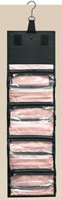Step 4: How much inventory do I need?

This decision is made by how many FACES per week/month you will be doing.

The GOAL is to have A ROLL UP BAG to sell for each face.

$4200 Order of Excellence* = 10 Roll Up Bags, Full Color + 4 specialty line items [50+ faces/month]

$3600 Emerald Star* = 10 Roll Up Bags, Full Color + 3 specialty line items [40+ faces/month]

$3000 Diamond Star* = 8 Roll Up Bags, Full Color + 2 specialty line items [35 Faces/month]

$2400 Ruby Star* = 6-7 Roll Up Bags, Most Popular Color + 1 spec line items [25 Faces/month]

$1800 Sapphire Star* = 5 Roll Up Bags, Limited Color [15 Faces/month]

*$1800 is the FIRST level where every woman will have the option to take a Roll Up Bag home, plus you are likely to have most of what each woman orders on hand to give to her immediately to run an efficient, time saving business. Remember, women buy alike, and the EYE BUYS what the EYE SEES. If each woman has the option to take home her OWN bag, chances are she will. Star Consultants re- ceive 1. Recognition (newsletter & website); 2. Star Consultant Prize from MK; 3. Get invitation to Star Consultant Outing with our unit; 4. Earn your Jeweled Calculator!

$1200 Order = 3 Roll Up Bags, very very limited Color

$600 Order = 3 Roll Up Bags, NO COLOR

Step 5: Make a Decision!

Let’s talk about your decision, and find a package that’s right for YOU and for your BUSINESS!

* + 1. There are many ways to invest, but here are my favorite options you can use to make your investment!
    2. Get a small personal loan. Credit Unions & small banks usually have the lowest rates.
    3. Apply for Fifth/Third Bank Credit Card

- 0% for 12 months and no annual fees - you can apply over the phone, They’ll give you the # the next day - say that you are a MK consultant, Call 859.299.5553 and ask for Scott Talley (or any manager if he isn’t available)

##### Inventory Planning

*Benefits of Having Full Departments*

* Immediate product delivery at skin care classes and facials (spend less on gas & save time & less frustration)
* Consultants who have product are both more committed to their business AND pay off their initial investment

more quickly because of that commitment Great customer service that keeps your customers coming back to you for reorders

* Anticipating the needs of new and existing customers by having all the appropriate products available
* Start with $1800 or more WS on first order and earn Jeweled Calculator
* Star Consultant Status = Star Consultant Prize (see color brochure), recognition & Star Consultant Outing

with the girls each quarter

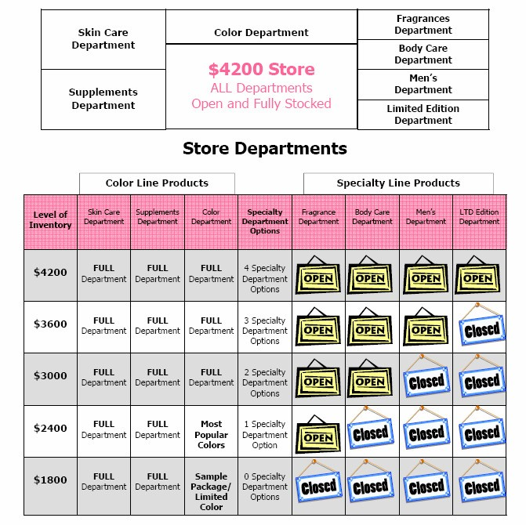

***N E W C ON S U L T AN T T R A I N I N G*** Inventory Decision

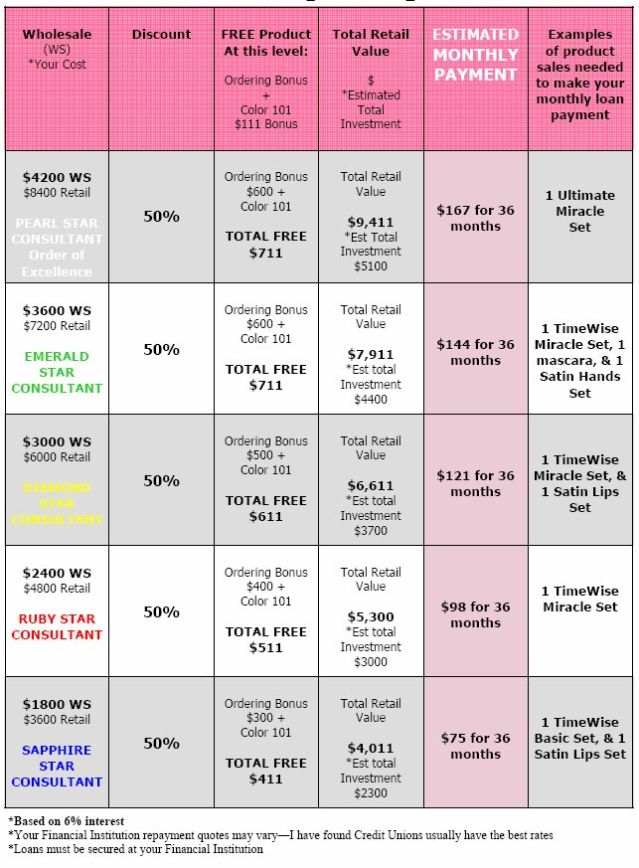

Choose to Promote Yourself and Move UP the Mary Kay Career Path!

Mary Kay Consultant

Congratulations you are earning 50% on any product sold!



Senior Consultant

1-2 Active Team Members; 4% Commission.

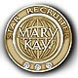Star Team Builder

3-4 Active Team Members; 4% Commission; The Red

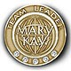Team Leader

5-9 Active Team Members; 9 or 13% Commission; $50 Team Building Bonus; The Red Jacket; Go On Target for Car!

Grand Achiever

You earned your FREE Mary Kay car! 14 Active Team Members + $20,000

in team production over 4 consecutive months!!

Future Director/DIQ



10 Active Team Members; 9 or 13% Commission; $50 Team

Building Bonus; On your way to Directorship!

Sales Director

24 Active Unit Members; 4, 9 or 13% Personal Team Building Commission; 13% Unit

Commission,10% Unit Volume Bonus, $100 Personal Team Building Bonus; $300-$500 Unit Team Building Bonus, Other Cash Bonuses, Commission from any

offspring Sales Directors, Life Insurance, Qualify for a FREE CAR, and

so much more!!!

National Sales Director

Must have a total of 20 Offspring Sales Directors. 4, 9 or 13% Personal Team

Building Commission, 13% Unit Commission, 10% Unit Volume Bonus, 2, 4, or 9% Commission from each Offspring Sales Director Other Cash Bonuses, Pink Cadillac, Life and Disability Insurance, Family Security Program, and so much more!!



**WHAT ARE YOUR MARY KAY PINS SAYING ABOUT YOU?**

Your Mary Kay Pins are a representation of your incredible accomplishments in your business and should be worn with pride. However, be careful not to over do it. Too many pins adorning your lapel can look clut- tered and distasteful. A good rule of thumb is no more than 3 pins including your Mary Kay Logo Pin. Your Ladder of Success Pin and Power Start Pin are always great choices!

##### A How to “Get Everything” Started

How do I log into the Mary Kay website?

Go to [www.marykayintouch.com](http://www.marykayintouch.com/) and you will need your consultant num- ber. Leave the password blank and hit connect.

How do I set up my Website?

Go to [www.marykayintouch.com](http://www.marykayintouch.com/) and log in as a consultant. You will have the option to purchase your website for $25 in the month you begin your

business and the month after.

How do I order professional business tools (business cards, etc…)?

Go to [www.mkconnections.com](http://www.mkconnections.com/)

How do I accept credit cards as payment?

Log into [www.marykayintouch.com](http://www.marykayintouch.com/) and on the home page scroll down and on the right hand side click on the ProPay link or call 800-630-8115

How do I order my product?

Your Director will place your first order for you. After that you can order on [www.marykayintouch.com](http://www.marykayintouch.com/) by clicking on the "Online Ordering" link at the top of the page or call 800-272-9333

How do I know if I'm active?

Log into [www.marykayintouch.com](http://www.marykayintouch.com/) and check your Personal Reports and your status will be next to your name or call 800-272-9333. You are active the month you have in at least $200 wholesale and the following 2 months. Only active consultants are eligible for their 50% discount. (Example, you place your initial order of $600 w/s in January 20—you are active and will receive your discount in January, February and March. If you do not place at least $200 w/s cumulative in any subsequent calendar month beginning in April will be considered “inactive” and will not receive your discount. HOWEVER, anytime you do have in at least $200 w/s within one month your activity “cycle” will restart!

How do I order my Red Jacket?

Call 800-619-0055

I have a problem with my MK email or website?

Call MK Intouch Support at 800-272-9333

My order was missing product or had extra product?

Call Branch Customer Service at 800-272-9333

STAR CONSULTANT-Climb the Ladder of Success!

Our Mary Kay year runs in 4 quarters. During each quarter every consultant has the ability to become a STAR Consultant!

• QUARTERS: 12/16-3/15, 3/16-6/15, 6/16-9/15, 9/16-12/15

Star Consultant is one of the most highly respected programs in our



Company. YOU will be awarded YOUR Ladder of Success Pin once YOU reach Star Consultant you first quarter. Each quarter you are a STAR you will receive the corresponding star charm!

**STAR CONSULTANT LEVELS**

**PEARL Star-4,800 contest points**

**EMERALD Star-3,600 contest points DIAMOND Star-3,000 contest points RUBY Star-2,400 contest points SAPPHIRE Star-$1,800 Wholesale**

NOTE: To achieve STAR you must have in a min. of $1,800 wholesale within the quarter. After reaching $1,800 wholesale, besides additional wholesale dollars, you will earn 600 points per new qualified team

members.

##### View Star Prizes in the Star Brochure you received in your Starter Kit or on intouch under main tab “Recognition and Contests” then click on “Contests” then “Star Consultant”

BENEFITS OF BEING A STAR CONSULTANT

1. Earn your Ladder of Success Pin!
2. Earn your Charm with genuine stone that corresponds to your star level!
3. Earn your Star Prize
4. Recognition in our newsletter, website, and at events!
5. Highly respected among sister consultants!
6. When you are a Star you are
7. making $ to put in your family’s pocket!
8. Stars drive FREE Mary Kay Cars!
9. You are setting an example for others to follow!

**Break it down…**

**Weekly Sales to be a STAR!**



**PEARL Star**

**$800 retail sales/week**

**EMERALD Star**

**$600 retail sales/week**

**DIAMOND Star**

**$500 retail sales/week**

**RUBY Star**

**$400 retail sales/week**

**SAPPHIRE Star**

**$300 retail sales/week**

***N E W C ON S U L T AN T T R A I N I N G***

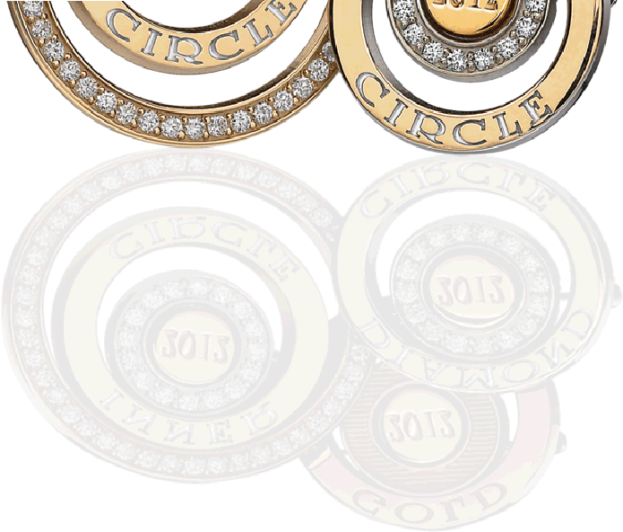

Your commitment to your business entitles you to participate in our **AREA INNER CIRCLE** Program.

**I have found that the best and the worst part of Mary Kay is the fact that you are not accountable to anyone!!! I love not having a boss— However, on the other hand I tend to do my best when I know someone is watching!!! This is the reason we designed our Inner Circle Program!!!! I will be watching each and everyone of you as you climb the Mary Kay Career Path!!!!! When becoming a Director is your goal and you are willing to be accountable to me, I would like to work with you!!!**

Somer Fortenberry

National Sales Director

Dates: Each Calendar Month

Cost: $10.00 or FREE when you completed the

previous Inner Circle Session

Prize: Receive a gorgeous prize for each month you achieve an inner circle!

Details: See somernsd.com for complete details, submission form and tracking sheet

|  |  |  |
| --- | --- | --- |
| **ELITE INNER CIRCLE**  **100% ATTENDANCE** | **UPPER INNER CIRCLE**  **100% ATTENDANCE** | **INNER CIRCLE**  **100% ATTENDANCE** |
| (MEETINGS, ETC.) | (MEETINGS, ETC.) | (MEETINGS, ETC.) |
| **5-5-5 PER WEEK** | **3-3-3 PER WEEK** | **2-2-2 PER WEEK** |
| 5 SELLING APPTS. | 3 SELLING APPTS. | 2 SELLING APPTS. |
| 5 INTERVIEWS | 3 INTERVIEWS | 2 INTERVIEWS |
| $500 RETAIL | $300 RETAIL | $200 RETAIL |
| ORDER $800.00 | ORDER $600.00 | ORDER $400.00 |

Create a Contact List—work from this list to invite people to your business debut and complete your Power Start! In addition to the obvious, your immediate family, in-laws, cousins, neighbors, friends and work associates, what about the person…

...from your old job

...from school or college

...you know from your favorite sport or hobby

...from your child’s activity

...from your church

...from community activities

...from whom you rent

...to whom you sold a house

...that you met through your

...who checks you out at the grocery

...who helps you at the cleaners

...that you met on vacation

...who checked you in at your last hotel

...who gives your child lessons

...who cuts your hair

...who fills your prescription

...who leads the PTA?

...Girl/Boy Scouts?

...who booked your last vacation?

...who sells baskets? candles?

...who bought a house last on your street?

...who is your bank teller?

...who is your florist?

...who was your nurse at the

office/hospital?

...who was your maid of honor?

...who is your cleaning lady?

...who you met in the grocery/

bank line?

...who was the bride you saw in the newspaper?

...who is your child’s/your friend’s child’s teacher

...who is the secretary at your work/school

...who sells you your clothes?

...who sells you your shoes?

...who sold you your glasses?

...who is the wait staff at your favorite restaurant?

...who you met at your last

business luncheon?

...who helped you at the last jewelry store?

...who helped with your last decorating purchases?

...the last salesperson to give great service?

...who works the desk at the

health club?

...who did I miss?

|  |  |  |  |  |  |
| --- | --- | --- | --- | --- | --- |
|  | **Name** | **Address** | **Phone #** | **Booked** | **Interviewed** |
| **1.** |  |  |  |  |  |
| **2.** |  |  |  |  |  |
| **3.** |  |  |  |  |  |
| **4.** |  |  |  |  |  |
| **5.** |  |  |  |  |  |
| **6.** |  |  |  |  |  |
| **7.** |  |  |  |  |  |
| **8.** |  |  |  |  |  |
| **9.** |  |  |  |  |  |
| **10.** |  |  |  |  |  |
| **11.** |  |  |  |  |  |
| **12.** |  |  |  |  |  |
| **13.** |  |  |  |  |  |
| **14.** |  |  |  |  |  |
| **15.** |  |  |  |  |  |
| **16.** |  |  |  |  |  |
| **17.** |  |  |  |  |  |

|  |  |  |  |  |  |
| --- | --- | --- | --- | --- | --- |
|  | **Name** | **Address** | **Phone #** | **Booked** | **Interviewed** |
| **18.** |  |  |  |  |  |
| **19.** |  |  |  |  |  |
| **20.** |  |  |  |  |  |
| **21.** |  |  |  |  |  |
| **22.** |  |  |  |  |  |
| **23.** |  |  |  |  |  |
| **24.** |  |  |  |  |  |
| **25.** |  |  |  |  |  |
| **26.** |  |  |  |  |  |
| **27.** |  |  |  |  |  |
| **28.** |  |  |  |  |  |
| **29.** |  |  |  |  |  |
| **30.** |  |  |  |  |  |
| **31.** |  |  |  |  |  |
| **32.** |  |  |  |  |  |
| **33.** |  |  |  |  |  |
| **34.** |  |  |  |  |  |
| **35.** |  |  |  |  |  |
| **36.** |  |  |  |  |  |
| **37.** |  |  |  |  |  |
| **38.** |  |  |  |  |  |
| **39.** |  |  |  |  |  |
| **40.** |  |  |  |  |  |
| **41.** |  |  |  |  |  |
| **42.** |  |  |  |  |  |
| **43.** |  |  |  |  |  |
| **44.** |  |  |  |  |  |
| **45.** |  |  |  |  |  |
| **46.** |  |  |  |  |  |
| **47.** |  |  |  |  |  |
| **48.** |  |  |  |  |  |
| **49.** |  |  |  |  |  |
| **50.** |  |  |  |  |  |

|  |  |  |  |  |  |
| --- | --- | --- | --- | --- | --- |
|  | **Name** | **Address** | **Phone #** | **Booked** | **Interviewed** |
| **51.** |  |  |  |  |  |
| **52.** |  |  |  |  |  |
| **53.** |  |  |  |  |  |
| **54.** |  |  |  |  |  |
| **55.** |  |  |  |  |  |
| **56.** |  |  |  |  |  |
| **57.** |  |  |  |  |  |
| **58.** |  |  |  |  |  |
| **59.** |  |  |  |  |  |
| **60.** |  |  |  |  |  |
| **61.** |  |  |  |  |  |
| **62.** |  |  |  |  |  |
| **63.** |  |  |  |  |  |
| **64.** |  |  |  |  |  |
| **65.** |  |  |  |  |  |
| **66.** |  |  |  |  |  |
| **67.** |  |  |  |  |  |
| **68.** |  |  |  |  |  |
| **69.** |  |  |  |  |  |
| **70.** |  |  |  |  |  |
| **71.** |  |  |  |  |  |
| **72.** |  |  |  |  |  |
| **73.** |  |  |  |  |  |
| **74.** |  |  |  |  |  |
| **75.** |  |  |  |  |  |
| **76.** |  |  |  |  |  |
| **77.** |  |  |  |  |  |
| **78.** |  |  |  |  |  |
| **79.** |  |  |  |  |  |
| **80.** |  |  |  |  |  |
| **81.** |  |  |  |  |  |
| **82.** |  |  |  |  |  |
| **83.** |  |  |  |  |  |

# Pearls of Sharing Tracking

Pearl Earrings—5 Interviews

Power Start Tracking

|  |  |  |
| --- | --- | --- |
|  | **Name** | **Sales** |
| **1.** |  |  |
| **2.** |  |  |
| **3.** |  |  |
| **4.** |  |  |
| **5.** |  |  |
| **6.** |  |  |
| **7.** |  |  |
| **8.** |  |  |
| **9.** |  |  |
| **10.** |  |  |
| **11.** |  |  |
| **12.** |  |  |
| **13.** |  |  |
| **14.** |  |  |
| **15.** |  |  |
| **16.** |  |  |
| **17.** |  |  |
| **18.** |  |  |
| **19.** |  |  |
| **20.** |  |  |
| **21.** |  |  |
| **22.** |  |  |
| **23.** |  |  |
| **24.** |  |  |
| **25.** |  |  |
| **26.** |  |  |
| **27.** |  |  |
| **28.** |  |  |
| **29.** |  |  |
| **30.** |  |  |
|  | **Total Sales:** |  |

|  |  |  |  |
| --- | --- | --- | --- |
|  | **Name** | **Follow Up Date** | **Decision** |
| **1.** |  |  |  |
| **2.** |  |  |  |
| **3.** |  |  |  |
| **4.** |  |  |  |
| **5.** |  |  |  |

Pearl Bracelet—5 Meeting Guests

|  |  |  |  |
| --- | --- | --- | --- |
|  | **Name** | **Follow Up Date** | **Decision** |
| **1.** |  |  |  |
| **2.** |  |  |  |
| **3.** |  |  |  |
| **4.** |  |  |  |
| **5.** |  |  |  |

Pearl Necklace—1st Qual. Recruit

|  |  |  |
| --- | --- | --- |
|  | **Name** | **Initial Order $600 w/s or more!** |
| **1.** |  |  |
| **2.** |  |  |
| **3.** |  |  |
| **4.** |  |  |
| **5.** |  |  |

New Consultant Training Tracking

|  |  |
| --- | --- |
| **Training** | **Completion Date** |
| **Read through NC Packet** |  |
| **NC Training Calls (all 6)** |  |
| **Attended NC Boot Camp** |  |
| **Silver Scholars Lessons** |  |

***N E W C ON S U L T AN T T R A I N I N G***

BEAT BOX PROGRAM!

Beat the Box! Get 12 Bookings before your Starter Kit Box arrives and earn a great prize from your Director!

Note: Kits usually arrive within 5 business days!

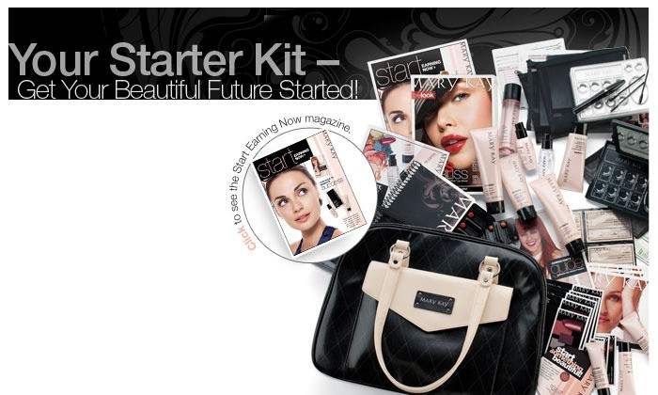

|  |  |  |  |
| --- | --- | --- | --- |
|  | **Hostess Name** | **Date** | **Phone Number** |
| **#1** |  |  |  |
| **#2** |  |  |  |
| **#3** |  |  |  |
| **#4** |  |  |  |
| **#5** |  |  |  |
| **#6** |  |  |  |
| **#7** |  |  |  |
| **#8** |  |  |  |
| **#9** |  |  |  |
| **#10** |  |  |  |
| **#11** |  |  |  |
| **#12** |  |  |  |

*I’ve shared the Satin Hands Pampering Set with the following people:*



*My Total Sales:*

Satin Hands Challenge

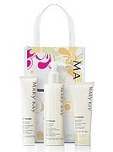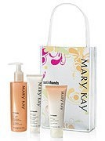

Sharing one of the hottest-selling Mary Kay products with potential customers is a great way to meet people and get your business growing. The Satin Hands Pampering Set samplers in your Starter Kit pro- vide an experience that not only leaves hands soft immediately, but also leaves a great impression on potential customers. Sharing them with 12 people is a quick and easy way to start a conversation about your new business. Then you can follow up to book another appointment to try more great Mary Kay products! You’ll want to exchange business cards or contact information so that you can follow up with great customer service.



“To succeed you need the qualities that are essential in any worthwhile endeavor: Desire amounting to enthusiasm, persistence to wear away the mountains, and the self-assurance to believe that you can succeed.”

*—Mary Kay Ash*

I held my Mary Kay Debut on the originally scheduled date with at least 15 guests (18 and older, doesn’t

include men)

Debut Ring

Sample Rings Pictured

I have completed all Silver Scholar Lessons for New Consultants– attended New Consultant

Boot Camp, and

completed all 4 New Consultant Training Calls. MK Sunglasses

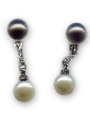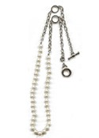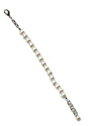

I Completed my first 5 practice Interviews with my Director (in first 30 Days) Pearl Earrings

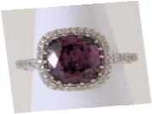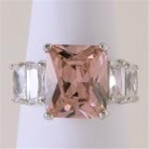

I’ve brought 5 guests to events (in first 30 Days) Pearl Bracelet

I have added my first

qualified* team member (in first 30 Days after debut) *Qualified- Initial Order of $600 or more Pearl Necklace

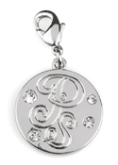

I Completed my Power Start

(30 Faces in 30 Days)

Power Start Charm

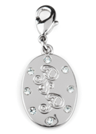

I Completed my Power Start Plus

(30 Faces & 6 Interviews in

30 Days)

Power Start Plus Charm



I started my business as a STAR ($1800+ w/s) MK Black Jeweled Calculator

**Instructions for New Consultant and Monthly Prizes:**

* + **All Prizes requests must be submitted vihawww.chandratresaugue.com Click on the Prize Request Form Page.**
  + Prizes must be submitted by the 5th of Each month for the previous month. *(Example: anything you earn in January MUST be submitted for no later than February 5th. If you forget and submit after the 5th-prizes will be distributed the next month.)*
  + We order very nice prizes and most companies require a minimum order amount so
  + ordering one or two items is not possible; if you earn a prize you must claim it or forfeit it.
  + Prizes are in a basket on the front table at meetings so please look through and take your prizes. After a month of being up front they will be pulled and you will no longer be able to get them. If you live in town and do not come to meetings and you want your prizes

mailed you will have to send Chandra $6.00 for shipping. That is for priority shipping and

delivery confirmation. Propay your shipping to [tresaugue@marykay.com](mailto:tresaugue@marykay.com) by the 5th of the month when you submit for your prizes.

* + **If you have any questions concerning prizes, please contact Chandra at** [**chandraprizes@gmail.com**](mailto:chandraprizes@gmail.com) **please include your name and email**

**address.**