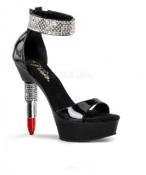S - ________________________________

H - ________________________________

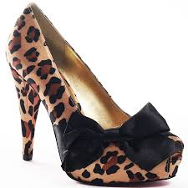O - ________________________________

E - ________________________________

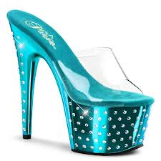D - ________________________________

I - ________________________________

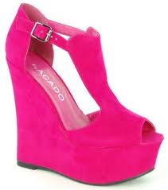V - ________________________________

A - ________________________________

Name ________________________________ Your Consultant _________________

Cell Phone # ______________________________ Ok to text ___Yes ___No

Email __________________________________________________________________

 *Please wait - Don’t fill the following info until directed to do so.*

After hearing the info, check the one that best applies to you:

**P -** I like **P**aying Full-**P**rice for my **P**roducts! I **P**refer to remain a **P**leased Customer, being loyal to my consultant!

**I - I** like FREE! **I**magine that! **I** would love to be a Hostess, have some girlfriends over and earn FREE product! **I** can’t wait! Book my party!

**N - N**eed more information. **N**ot saying “**N**o” yet. Follow up with me in the **N**ext 24-48 hours and I might be your **N**ext recruit!

**K** - I’m not **K**idding! I’m ready to **K**ick it up! I could **K**iss you for telling me about this opportunity! Sign me up today!

DIRECTOR GUIDE – These are suggestions. You can create your own and elaborate on these as you see fit.

One way I do it is have them write down a reason that starts with that letter (doing all the letters in SHOE DIVA) and then, as I do each letter, ask first who has an answer. I give everyone who has a good answer a ticket but if they have MY answer, they get 2 tickets! You can only do that with a small group. If you have a bigger group, then you could give out a ticket to the 1st 3-5 answers from the group, again giving 1 for a good answer (all of them) and 2 for MY answer. OR give everyone who puts something on every line a ticket.

Again, do it as you see fit.

Debra Bishop

S – SELF EMPLOYED BENEFITS – Tax breaks, build business as you wish, You are your own BOSS!

H – HAPPY – We love what we do! Girlfriends, Fun, Travel, etc

O – OWN BOSS -

E – ESTEEM, As in Self Esteem or EDUCATION – Excellent training, locally and from MK

D – DRIVE FREE

I – INCOME - Money

V – VIRTUES – Priorities of God, Family, Career – Golden Rule

A – AWARDS - Pri[zes](http://www.crosswordsolver.org/definition/H/howitzers) and Recognition