Facebook Party tips

- Create the event under Events on Facebook. Set it as invite only (otherwise it shows up in EVERYONES newsfeed and looks spammy!) and individually invite your personal friends. Once someone is invited to an event, they can also invite friends. You will have better success if you send private messages and then invite people than you will if you just mass invite your entire friends list.
- Only invite people once they have said yes to your private message. This keeps the event exclusive and also ensures that people’s inboxes aren’t blown up by 300+ notifications from an event they weren’t even interested in attending. (it’s a courtesy!!)
- Here is the script that I use to send via private message to the gals I am inviting. You have a much better response with individual messages than by mass inviting:
  - [Hey Sunshine! Love seeing the videos and pictures of your family! So fun to grow up with lots of siblings]
I'm reaching out because I'm hosting a Mary Kay online interactive product preview party tonight (Wed) at 9PM CST and wanted to see if you would be interested in jumping online as my guest?! This is a brand new format for us--embracing technology & I've been selected by the company to then train women across the country on how to do it ... so would love to have some fun, intelligent women give me feedback! How it works -- at the time of the event you will log on to the Facebook event and we will be sharing some great information about our skincare products, there will be a few interactive questions, PLUS for being on live you will be entered into a drawing for FREE Mary Kay products & a Coach handbag just for logging on! Would you be interested in participating with us ? It is going to be easy and fun all in the comfort of your home (hopefully with some comfy clothes LOL) Let me know ASAP if you are willing to participate ... Thanks for considering and I hope your day is fabulous !

3. I usually post a “teaser” video a few days or hours before the event (depending how far out I have scheduled the event…FB events can have a super fast turn around!) Sometimes I do more than one (for instance if the event is a week away I might post two or three teasers to build anticipation and excitement). When people comment on these they are entered into the free product drawing. My favorites are the ones about Mary Kay Ash herself or the company…tons available on the Mary Kay You Tube channel!
- I keep track of entries into the drawing on the page at the bottom of this document…numbered 1 through 100…I write their name next to a number as they comment. When done with party and ready to draw I use the site random.org and their random number generator to pick a number…whoever’s name is by the number is the winner. They pm me their address and I mail their prize. I do 1-4 giveaways depending on how many guests are on live.
- If you are working with a hostess who invites her friends, don’t leave the party open too long…people forget to order. Instead close it right away.
- Here is my hostess plan I have been utilizing with FB parties…very similar to our typical plan: Super excited to partner with you for the facebook party! I have created the event and sent you an invite...you should be able to invite your friends now. In the next message I'll give you a script that you can use to private message the gals that you are inviting. Here's the scoop on hostess credits... all of you will be entered 1x for the COACH bag at the end of the party. Plus you and your guests will be entered for free product each time you comment or post during the party. You also get hostess credits of up to $100 free ($40 free for having at least 10 people on live, $30 free for at least $300 in sales, $30 free for having at least 3 people who book their own parties...either fb or otherwise) You will receive a $50 free product bonus if you or someone you invite to the party chooses to join my Mary Kay organization!
  - Here is the message that the hostess can send to her friends:
    - here is a great script to send via private message to the gals you are inviting to your party. I’ve found you have a far better response doing individual messages rather than just mass inviting your entire friends list ;): Hey Sarah! I'm hosting a Mary Kay online interactive product preview party on Sunday at 7 pm and wanted to see if you would be interested in jumping online as my guest?! How it works -- at the time of the event you will log on to the Facebook event and we will be sharing some great information about our skincare products, there will be a few interactive questions, PLUS for being on live you will be entered into a drawing for FREE Mary Kay products and a Coach handbag. Would you be interested in participating with us?! It is going to be super fun!! Let me know ASAP so I can get you invited to the event & my consultant Elissa can get you entered into the participant drawing!! Thanks friend!
- Your most successful unit/group parties will happen when you coach your consultants to close via private message just as they would at a regular guest event.
- It’s helpful to leave the post numbers on so late comers can catch up.
- I “pin” the post we are working with to the top of the page to eliminate confusion.
- I post the create a roll up bag picture with the Post 8. I don’t send customers to the website any more…they pm which sets they want instead==HIGHER SALES! (Actually my FB party per face average is higher than my in person average at the moment…INSANE!!!!)
- Have fun and be flexible! You will experience an insane adrenaline rush from the success of these! It’s crazy! Be creative and add your own “spin”…my FB parties are constantly evolving!! I’m sure you have ideas I haven’t thought of!!

Outline (just includes main posts, not my comments that I use to transition ☺ Be creative!)

Post 1: Welcome everyone! I’m SO glad you’ve joined us for the LIVE Online Mary Kay Facebook Party!!

One key to making this work tonight is to continuously “refresh” the page you are seeing so you see the newest posts as they appear! I will “pin” whatever post we are working with to the top of the page.

When you participate with us tonight you will be entered to win some fun free products! Plus you at the end you will be able to enter for a COACH handbag …pretty sweet!

You also have the chance to book an Ultimate Pampering Session with your consultant tonight…if you are local to her, that session will be where you and your guests will personally try out our hand treatment, 2 step lip treatment, complete skincare session, and a flawless color finish! If you aren’t local to her, that session will include a custom mailed sample set to try with friends. If you are interested by the end of the party, make sure you let us know and we will get you additional entries for free products!

There are going to be a few interactive parts to this party, make sure you participate so you are entered to win FREE prizes!

To start with, I’d love to know who is here and what you already know about Mary Kay. If you are a guest, go ahead and tell us your name and share your favorite Mary Kay product if you have one! BTW—you’ll get an entry into the free product drawing each time you participate by posting a response or a question! Consultants, if you could encourage our guests by liking their posts that would be awesome!

I’ll go first: My name is Elissa Martin, and I’m currently a Senior Cadillac Sales Director with Mary Kay. I’ve been building my business for almost nine years and driving FREE courtesy of Mary Kay for over 5 years now. I live in Callaway, Nebraska. I love that I’ve been able to give myself more freedom and income opportunities with my MK business, and I enjoy teaching and mentoring women. I can customize my business into EXACTLY what works for me, which allows me to live the priorities of my faith, my family, and then my career. I have an awesome husband Patrick who is a cowboy, and a sweet ten month old daughter, Lucy. I love ALL of our products but right now I am totally in love with our new Skinvigorate cleansing brush, because it is so fun and my face feels squeaky clean after I use it!

Post 2:First up is our most popular gift item…perfect for Easter Baskets! Satin Hands…in peach or fragrance free. Comment below which scent best fits you!
http://www.youtube.com/embed/ljrTZhC2h5Y

Post 3: Next we are going to talk about skincare! Did you know that our skin starts to break down collagen and age faster in our early 20s??? YIKES!! Make sure you are slowing down that process!
Watch this video if you are 18-20s
http://www.youtube.com/embed/teLmEXxzd1s?rel=0
Watch this one if you’re over 30:
http://www.youtube.com/watch?v=37c5KmhhLVU&list=PLA15CD0F094436CF1&index=16

Make sure to comment back here when you are done for entries into the drawings!

Post 4: Here it is! My favorite product! The Skinvigorate Brush!! LOVE!!!!
Remember to keep commenting for more entries!
http://www.youtube.com/embed/0_xqxPANJXk?rel=0

Post 5: This is another one of my favorite products, and one of our best-sellers, the MICRODERMABRASION! It’s an instant gratification, face lift in a bottle! Check it out: http://www.youtube.com/embed/yFB2aG17g_8?rel=0

Post 6: Ok we are going to finish out the skincare part with the final step in our skin care routine…anyone know what that is?

It’s foundation! Lots of people think it is color but it’s really skincare. Here are some great foundation options:
https://www.youtube.com/watch?v=X97w0H366rY&feature=c4-overview-vl&list=PLA15CD0F094436CF1

Post 7: I want to give you a couple of chances to get a ton of entries for the drawing! Go ahead and pull up your private message on your facebook page and create a message to your consultant! When you message her the names and phone numbers of the five most motivated women you know, you will get 5 entries for free product! Consultants post here when your guest has messaged you and we’ll get her into the drawing!

Post 8: We are going to finish out our product part by showing you some specials!

Notice on the sheet that when you pick any two sets you are a DUCHESS and get the eyemakeup remover for free, any 4 sets you are a PRINCESS and get a free roll up bag and about $70 in savings, and any 6 sets you are a QUEEN and get a free roll up bag plus $137 coupon! Comment below whether you feel like a Duchess, a Princess, or a Queen!
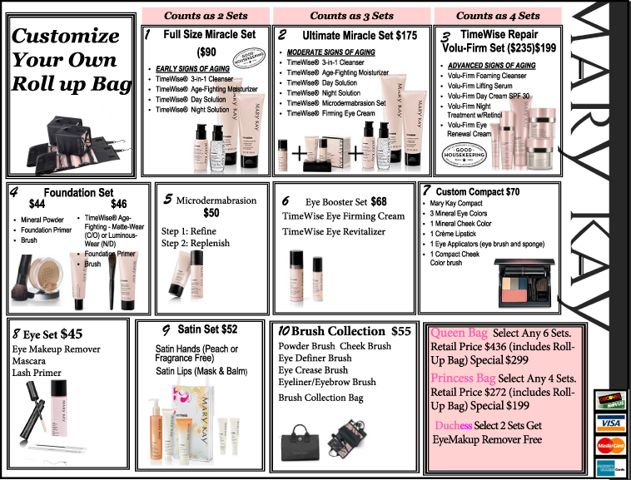

Post 9: I want to give you a few more chances for entries so we can do a couple more drawings! Who is ready to connect with their consultant in person to try these products themselves? If you book your appointment in March you get some extra special hostess perks! Comment below if you want to set up your appointment and get five more entries into our drawing!

Post 10: The last part of our event is called million dollar question! I’m going to give you 6 facts about Mary Kay as a business and then you are going to ask me questions! You’ll get an entry for each question you ask and I’ll choose some of them to answer here. Ready??

- Mary Kay is #1 in skincare and cosmetics for the last 15 years!

- We don’t have two things that a lot of direct selling companies have…territories and quotas! Never had them, never will.

- We have three ways to make money! We can sell product and we make 50% of everything we sell. We can also build a team, so the company pays us for helping our team to be successful. Finally we can move into leadership and mentor and coach other women as an executive!

- How much time does it take? That’s completely up to each consultant! You get to pick what works for you, and you get out of MK what you put into it.

- How much money can you make? Again…the sky is the limit. Most consultants make $50-$100 an hour when they are showing the product. Sales directors can make anywhere from $2000 to $25000 a month leading their organizations.

- How do you get started? That’s easy! You order a STARTER KIT! It costs $100 and comes with over $400 of product to show, plus you get a mentor and success coach to help you.

Ok ready for million dollar question? Start asking!!

Post 11: Last thing I need you all to do for me so I can put you in the drawing for the Coach bag! Guests I need you to private message me your name, your phone number, and your consultants name. Consultants, if you could private message me your name, your phone number, and your directors name! We will get you entered!

Thanks again for being part of our first Facebook party! Even though we are officially done, I will be available here for the next 30 minutes to answer any questions you have while you continue to private message with your consultants!

Thanks again everyone!

Post 12: And our free product WINNERS are…

Other videos:
CC Cream
https://www.youtube.com/watch?v=ll9CdJragTU&list=PLA15CD0F094436CF1

Spring Trend Report with Luis Casco and Hello Sunshine Collection
https://www.youtube.com/watch?v=kxSRTgi6NYU&list=PLA15CD0F094436CF1

Check out our Mary Kay mascara portfolio:
https://www.youtube.com/watch?v=O2XwLi9b9Kk

Lipgloss:
http://www.youtube.com/embed/THYuAZx5qEQ?rel=0

For other videos go to youtube and type in Mary Kay…over 300 company made videos with products, etc!

- .
- .
- .
- .
- .
- .
- .
- .
- .
- .
- .
- .
- .
- .
- .
- .
- .
- .
- .
- .
- .
- .
- .
- .
- .
- .
- .
- .
- .
- .
- .
- .
- .
- .
- .
- .
- .
- .
- .
- .
- .
- .
- .
- .
- .
- .
- .
- .
- .
- .
- .
- .
- .
- .
- .
- .
- .
- .
- .
- .
- .
- .
- .
- .
- .
- .
- .
- .
- .
- .
- .
- .
- .
- .
- .
- .
- .
- .
- .
- .
- .
- .
- .
- .
- .
- .
- .
- .
- .
- .
- .
- .
- .
- .
- .
- .
- .
- .
- ..
- .
- .
- .
- .
- .
- .
- .
- .
- .
- .
- .
- .
- .
- .
- .
- .
- .
- .
- .
- .
- .
- .
- .
- .
- .
- .
- .
- .
- .
- .
- .
- .
- .
- .
- .
- .

