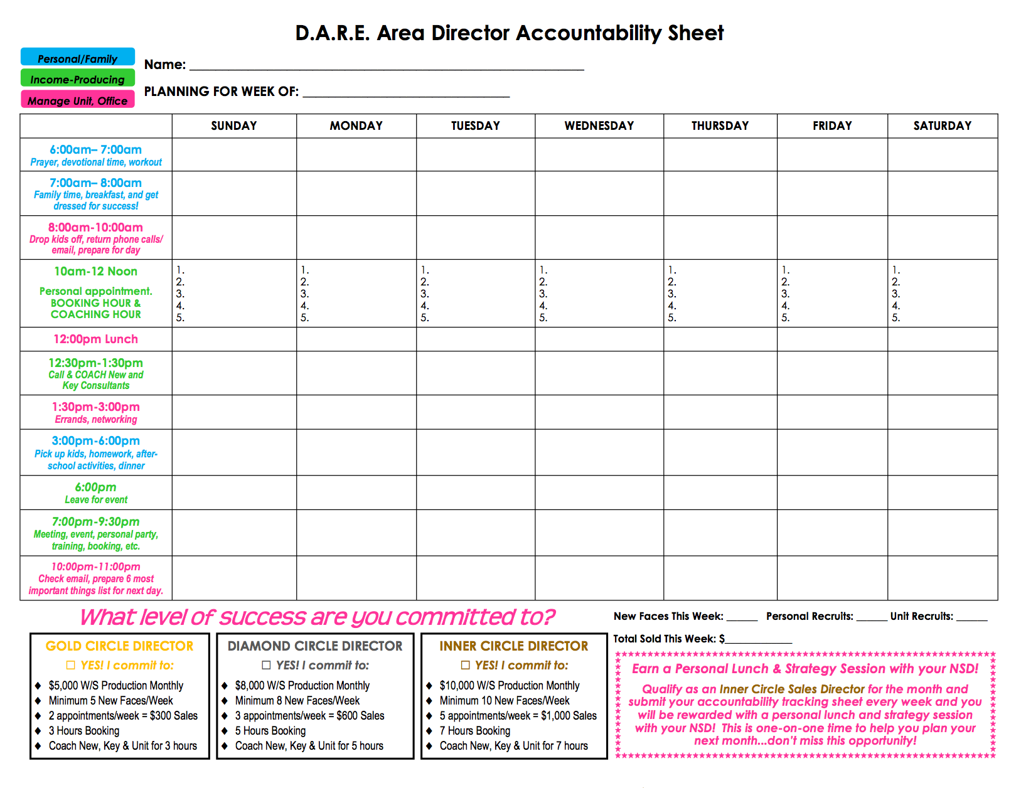

**Future Dynamic National Area Director Accountability Sheet**