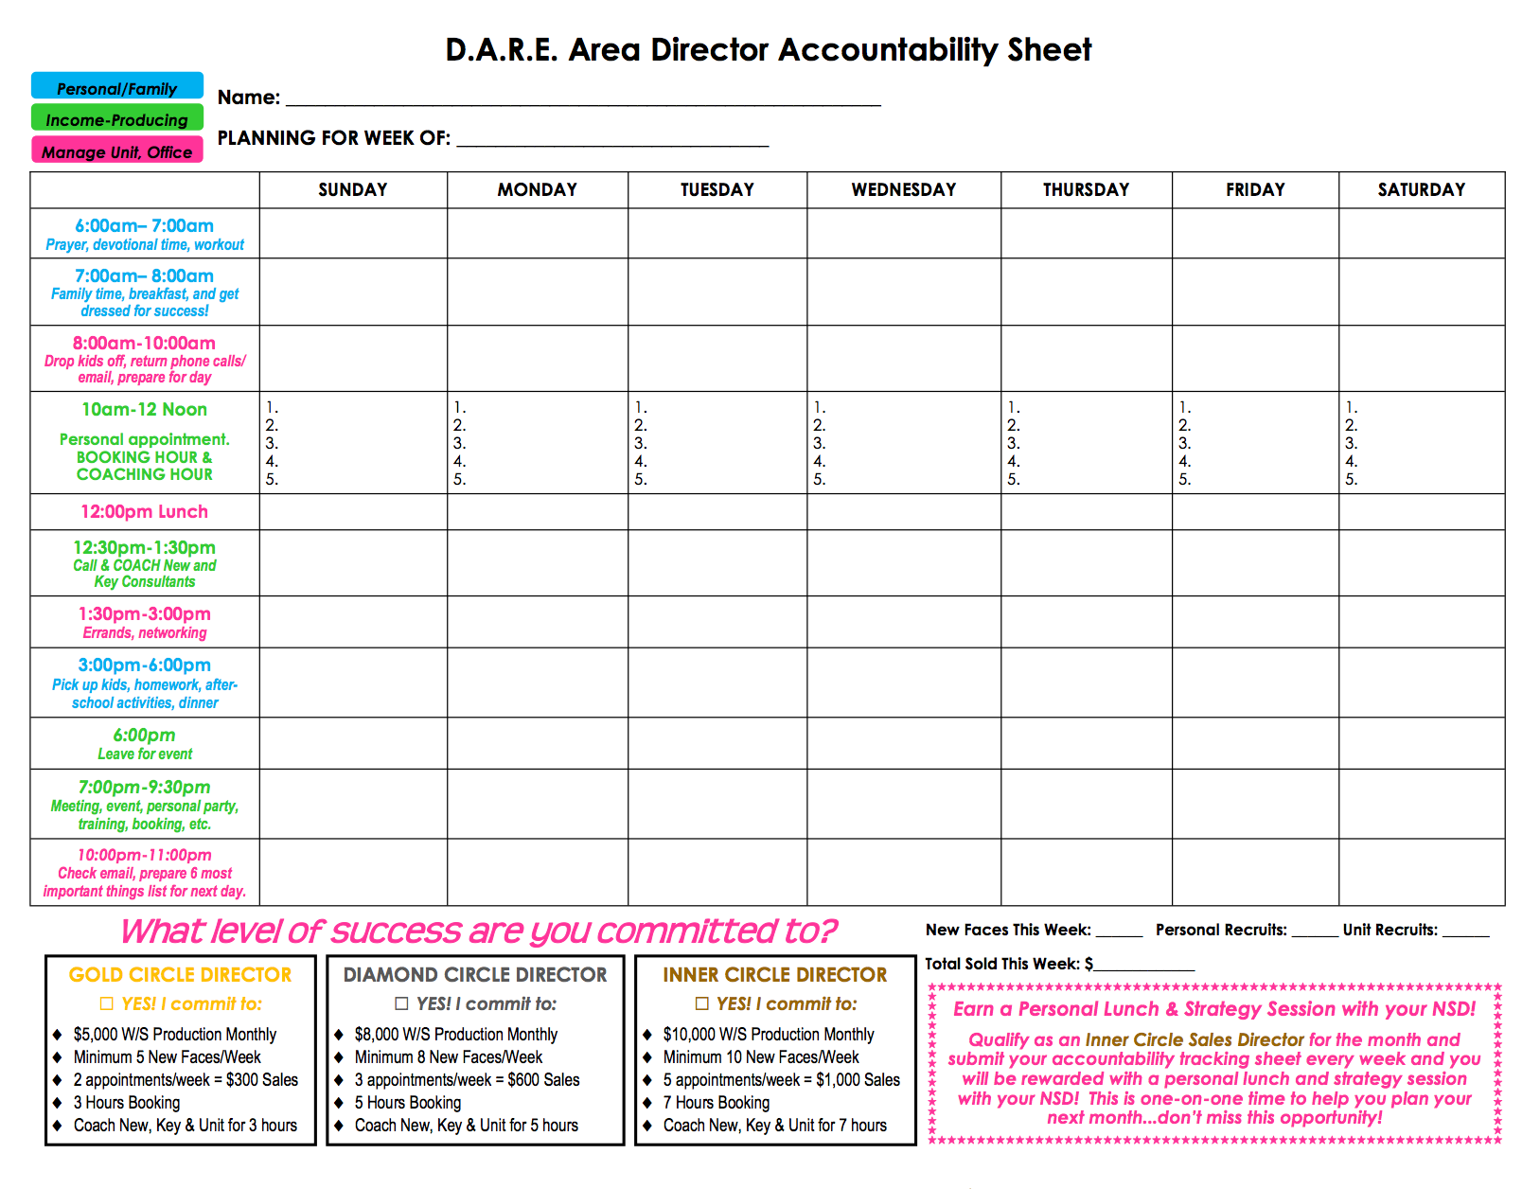

**Future Dynamic National Area Consultant Accountability Sheet**

**Coach Skin Care Class Hostesses, Call Director & team members**

**Personal apt, BOOKING & Follow Up Calls**

New Faces This Week: ___________

Total Sold This Week: $_____________

Total Guests at Meeting This Week: ____________

Total Guests on Marketing Calls This Week: ____________

Total Interviews Completed with Director this Week:_______

Personal Recruits: ______________

Star Recruiter/Team Leader

YES! I commit to:

* 5-8 New Faces/Week
* 2-3 appts./week =$300 Sales
* 2-4 Hours Booking, Follow Up Calls
* Attend Unit Meetings & Success Events every week
* Call Director 2-3 times per week

Part Time Consultant

YES! I commit to:

* 1-2 New Faces/Week
* 1-2 appts./week =$100 Sales
* 1-2 Hours Booking, Follow Up Calls
* Attend Unit Meetings & Success Events
* Call Director every week

Future Director/DIQ

YES! I commit to:

* 8-10 New Faces/Week
* 5+ appts./week =$1,000 Sales
* 4-6 Hours Booking, Follow Up Calls
* Attend ALL Unit Meetings & Success Events and Training Opportunities
* Call Director & team members daily