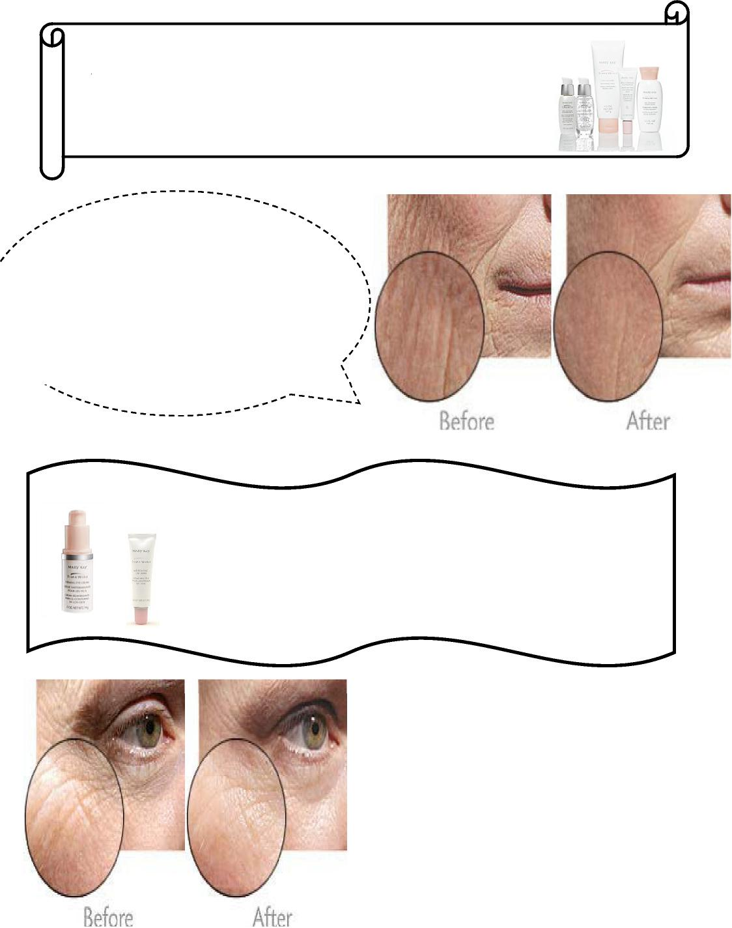

MIRACLE SET RESULTS
$104

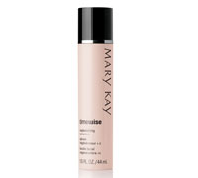
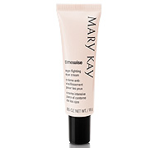
FIRMING EYE CREAM $30
AGE-FIGHTING EYE
CREAM $26~

Up to 25% INCREASE IN SKIN FIRMNESS
100% SOFTER, MORE SUPPLE SKIN
46% IMPROVEMENT IN MORE EVEN
SKIN TONE

Firming Eye Cream
Rich eye cream so advanced it firms,
brightens, provide intense Moisturization,
Plus minimizes fine lines and wrinkles.
96% participants saw an improve in the overall
appearance of the skin around their eyes.

Age Fighting Eye Cream
Lightweight eye cream minimizes fine
lines around the eyes for a younger
look. 9 out 10 women saw less-
noticeable fine lines and wrinkles.

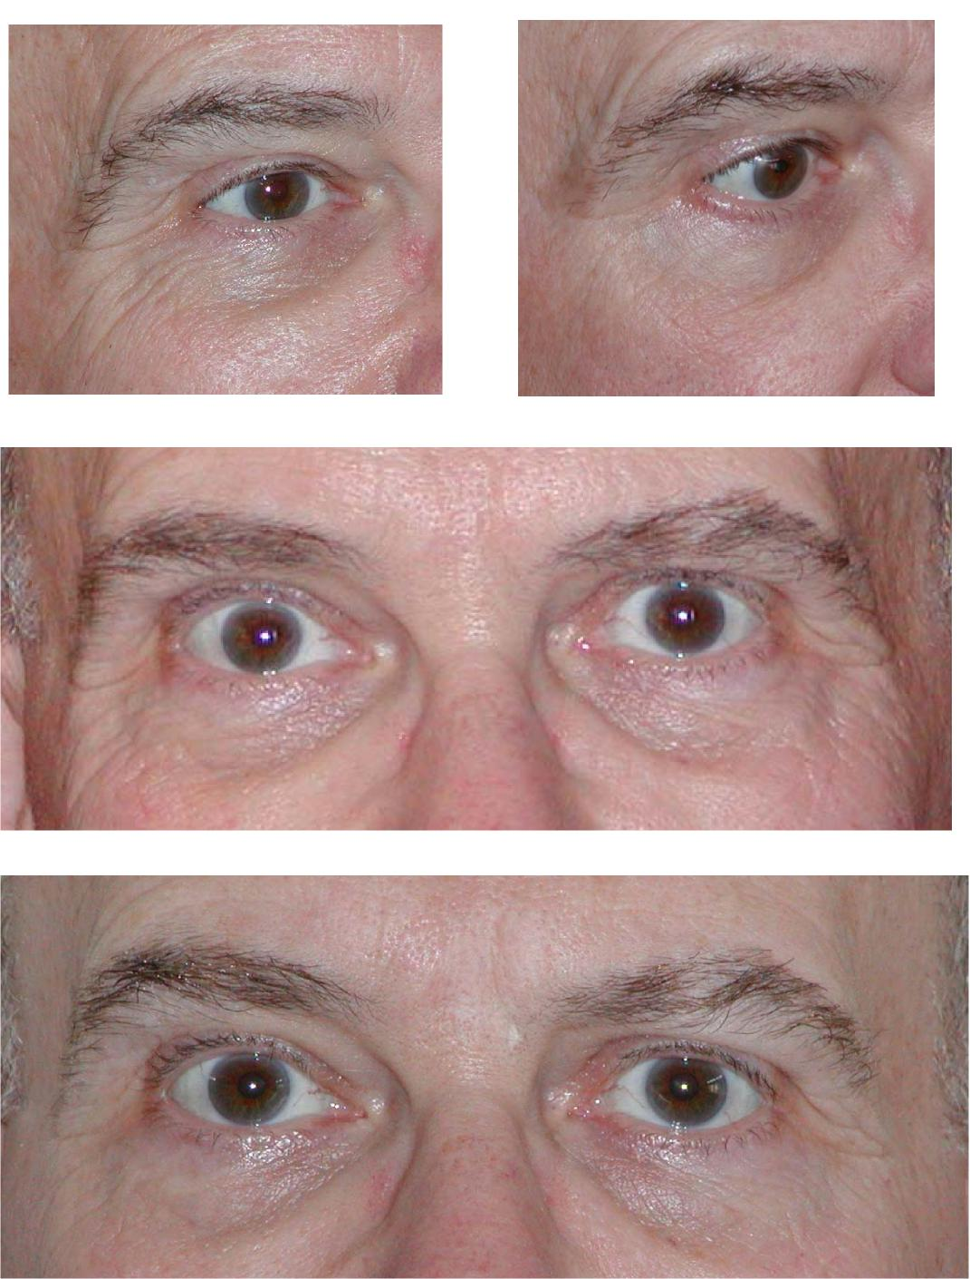
Before any eye products; October 2006 Firming Eye Cream (5 months) and Line Reducer (3 wks)
October, 2006—No eye products at all. Before picture.
Bill Scott - Eye Experiment
March 31, 2007  This eye began Firming Eye Cream in  October, 2006. He added Targeted-Action  Line Reducer three weeks ago. | Bill Scott is the husband of Senior Director Donna Bayes-Scott. Bill is a chemistry and physics instructor at Fort Hays State University, Hays, KS | March 31, 2007  This eye began Firming Eye Cream in January  2007, but has had no Line Reducer. Each product  has its benefits, but together, they are amazing!

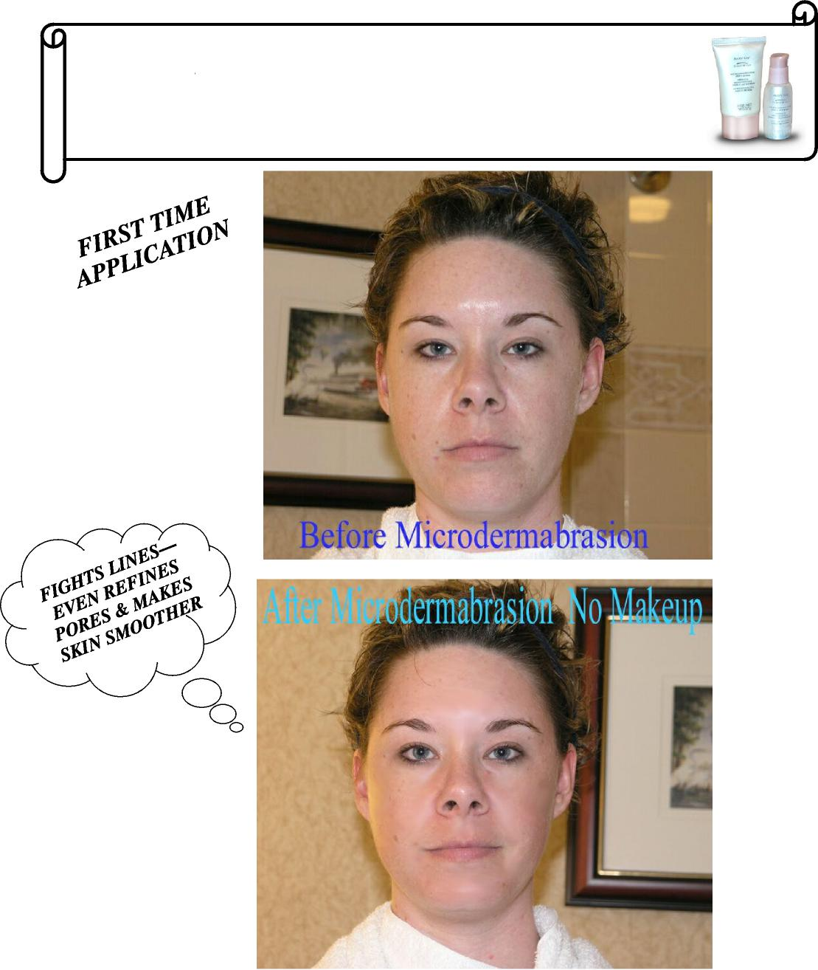
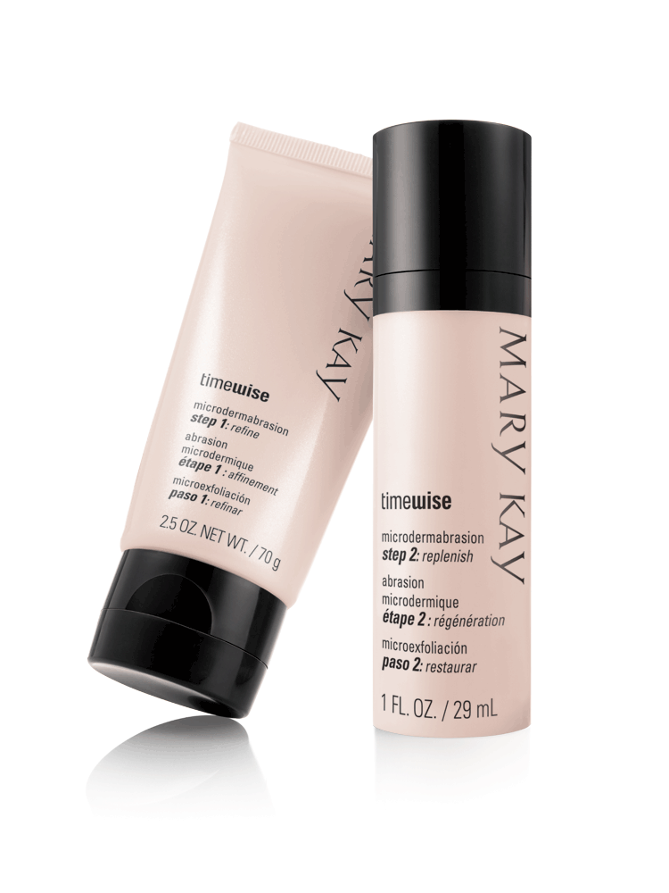
MICRODERABRASION
SYSTEM $55
THESE RESULTS WERE EXPERIENCED AFTER JUST ONE WEEK
85% improvement in skin texture
73% reduction in fine lines
71% smaller pores

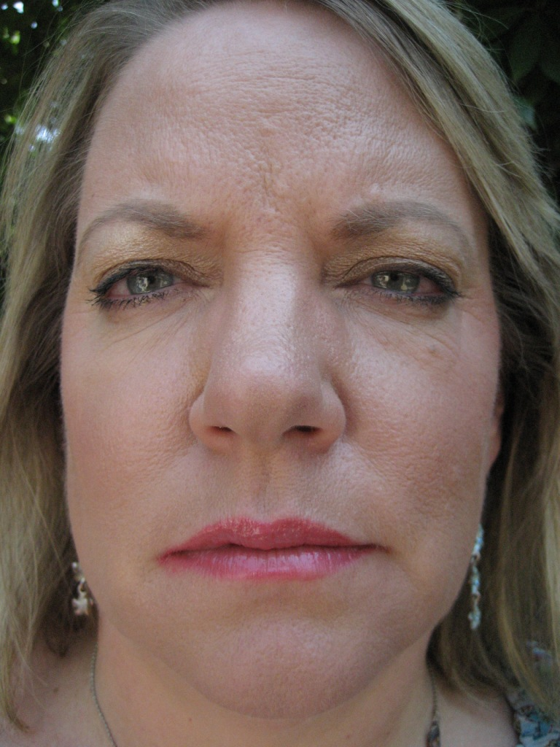

AFTER BEFORE
For 9 days now I have applied Mary Kay’s new TIMEWISE REPLENISHING SERUM+C ONLY to the right side of my face. Can you see the results? I have been asked by many,
“What have you done to your face?”
COST: $55
BENEFITS: PRICELESS

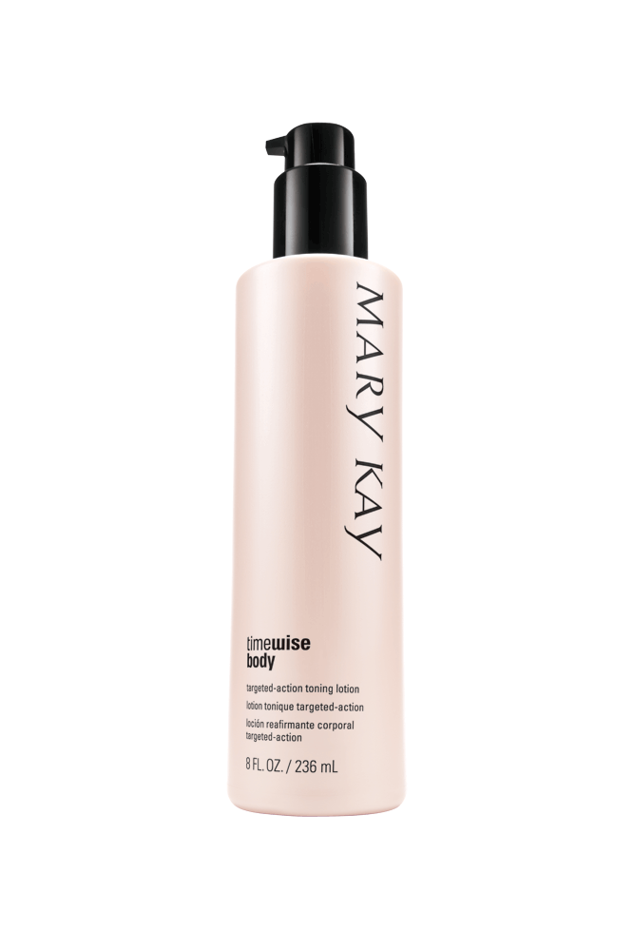

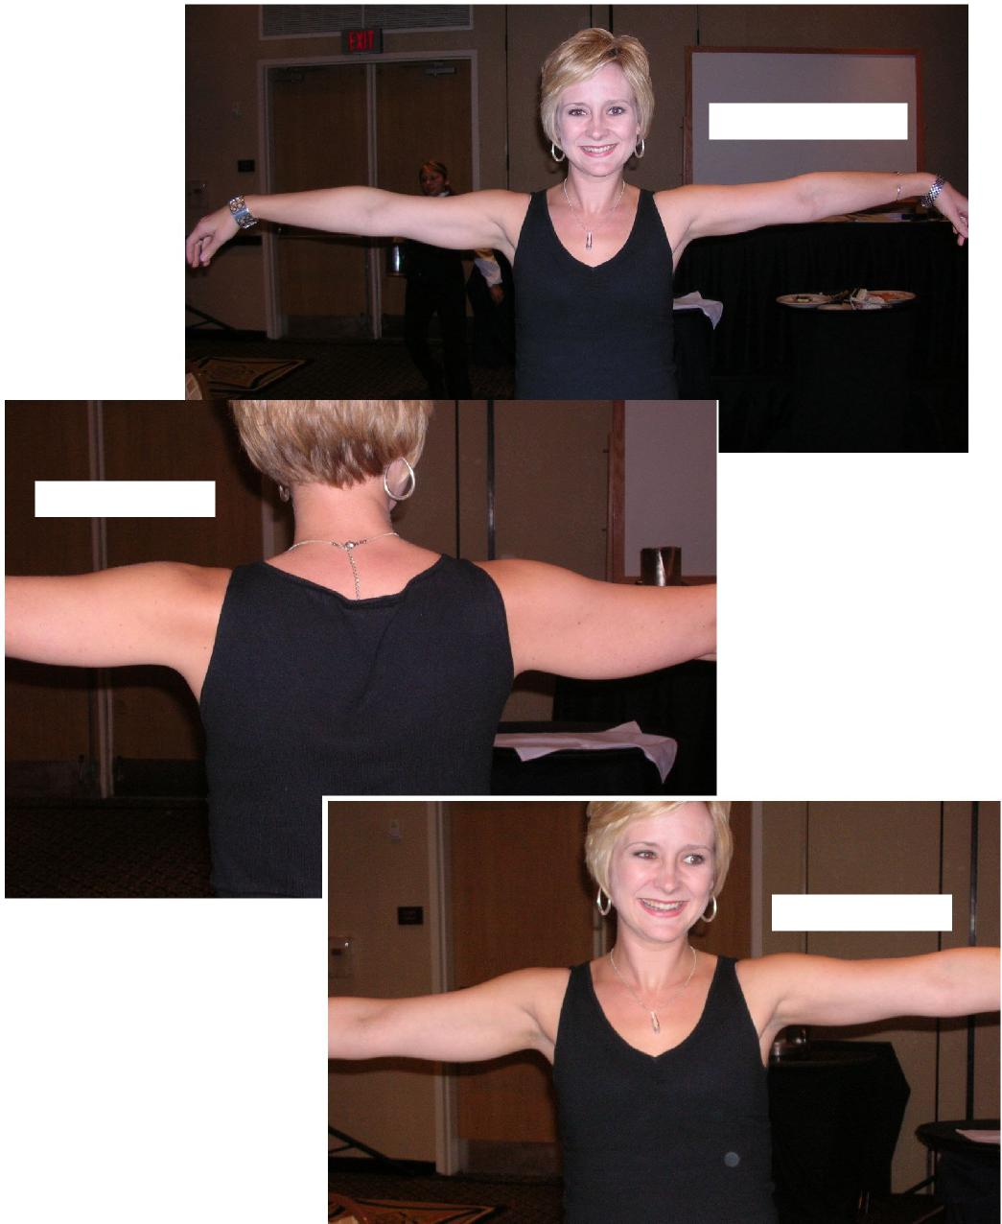
Toning Lotion Side!!
Toning Lotion Side!!
Toning Lotion Side!!

