Leap into Leadership!

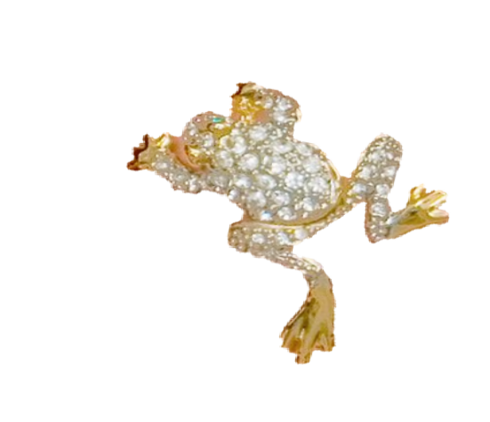

**A “Toad”-ally awesome “Girls on Fire” Challenge of the Month!**

**Earn the *legendary* Frog Pin by completing both of the following…**



# Place a $600 w/s cumulative order in April!



**Lucky 13 LIVE Interviews in April!**

1. Face to Face with your Director



1. 3-­‐way call with your Director
2. Guests to events

