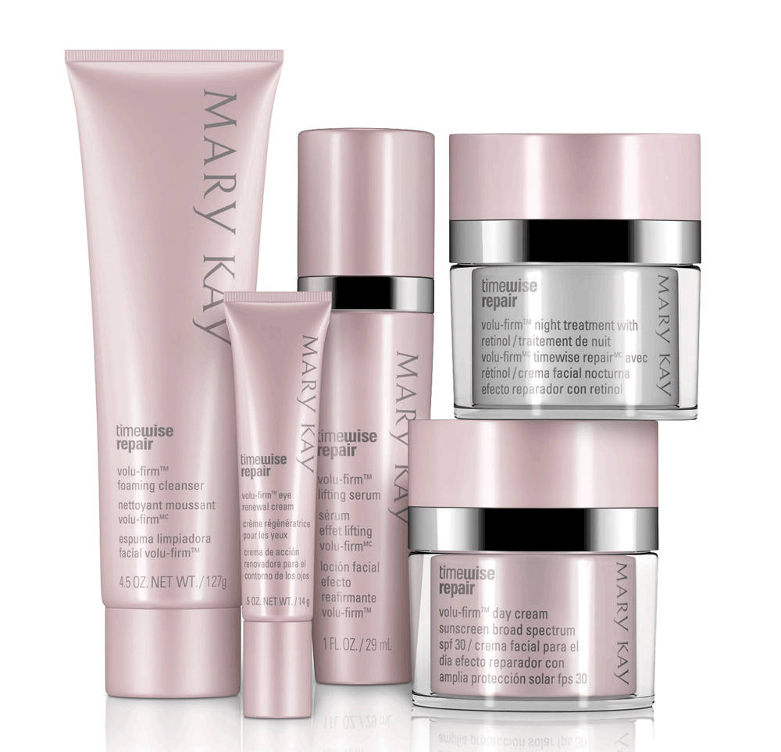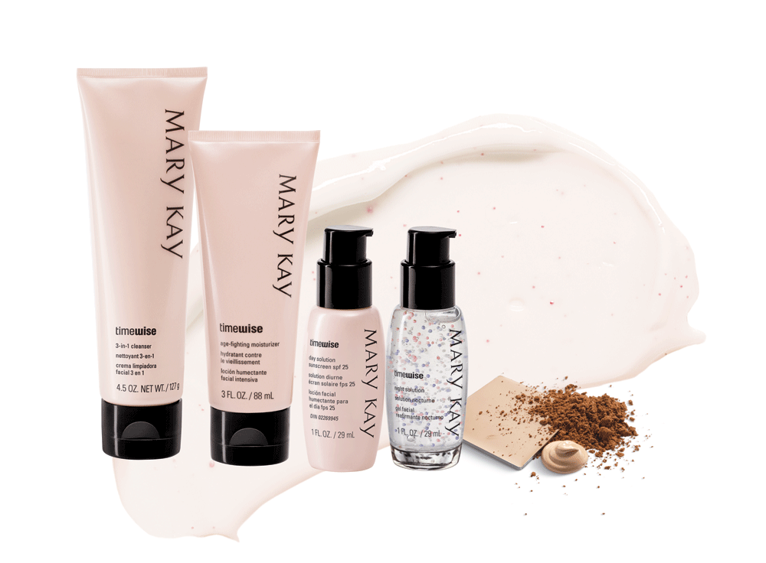
1,000 New Unit Customers!! Facial, website, or book order…Each customer with $40 in sales counts!
Rules: - Put on PCP list or customer list on InTouch
- $40 retail sales
- Contact me to report in!
10/month = $10 in free new Mary Kay from me
20/month =$20 in free new Mary Kay from me
30/month = $30 in free new Mary Kay from me
Plus, for every 5 customers, you will earn a ticket for a prize drawing!
Name Number $ PCP Name Number $ PCP Name Number $ PCP
1. 11. 21.
2. 12. 22.
3. 13. 23.
4. 14. 24.
5. 15. 25.
6. 16. 26.
7. 17. 27.
8. 18. 28.
9. 19. 29.
10. 20. 30.

