Listed below are ideas to help you network and get started with your prospect list!!!
Friends
Relatives
Associates from work
Neighbors
Kids - parents from school, sports, etc.

Of course, do not forget about:
- local businesses
- professional services you give your money to (they can help you out back)
- alumni from high school, college, previous jobs or trades
- organizations such as girl scouts, PTA, etc.
- fellow friends and members of church

There are also lots of other ways to get leads such as:
- lead boxes at local businesses
- warm chattering on your normal every day running of life (grocery store, bank, post office, etc.)
- finding fair booths, bridal fairs, craft shows, etc. in the local papers or around your area

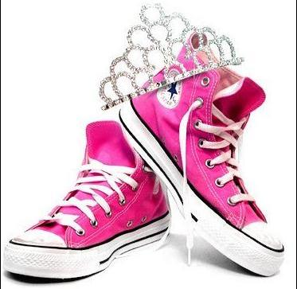
REFERRALS! Are the best way to get a lead! People do business with people they know, like, and trust! If you are calling someone that has been referred to you by someone else… you are much more likely to get that persons business!

NOW, crowns require running shoes!
So, get out of your house and get to work!

