SHAPING YOUR EYEBROWS CORRECTLY:

To get brows in shape, you can have them waxed by a professional or tweeze them yourself. Using a pencil as a guide, here’s how beautiful brows shape up.
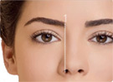
Hold a pencil upright along the side of the nose. The brow should begin at the line where the pencil intersects the inner corner of the eye.

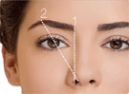
Next, angle the pencil from the tip of the nose to the middle of the iris. The brow should arch highest at the point where the pencil crosses the brow.
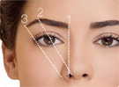

Finally, angle the pencil so it touches the outer edge of the nostril and intersects with the outer corner of the eye. This is where the eyebrow should end.

