How to make a Mary Kay® Timewise® 3 in 1 Cleansing bar Reindeer

Are you ready to "WOW" your customers this holiday season? If so, then follow this simple Reindeer giftwrap idea to really stand out. This is a great way to show your customers what you can do and make sure that they think of you every time Christmas comes around. Enjoy!

What you will need

Brown or tan washcloth .50 or $1

Wiggle eyes 30 for a $1 or $.04 an eye, I chose the 10mm size, but you could go bigger.

Pom-poms 100 for $1 or $.01 per nose, I chose 6mm size, and of course you could choose any size.

Pipe cleaner’s 6mm for 25 or $.04 each (you will use 4 per reindeer)

Total cost for wrapping supplies $1.25 with a $1 wash cloth or $.75 with a $.50 wash cloth.

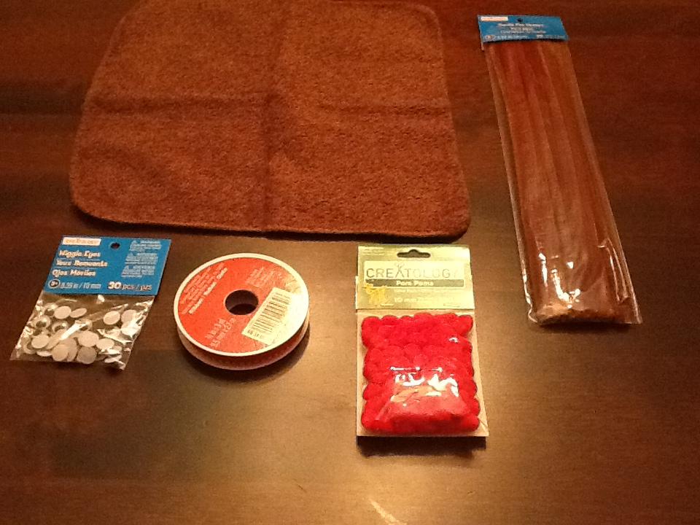

And of course you Mary Kay® Timewise® 3 in 1 Cleansing bar

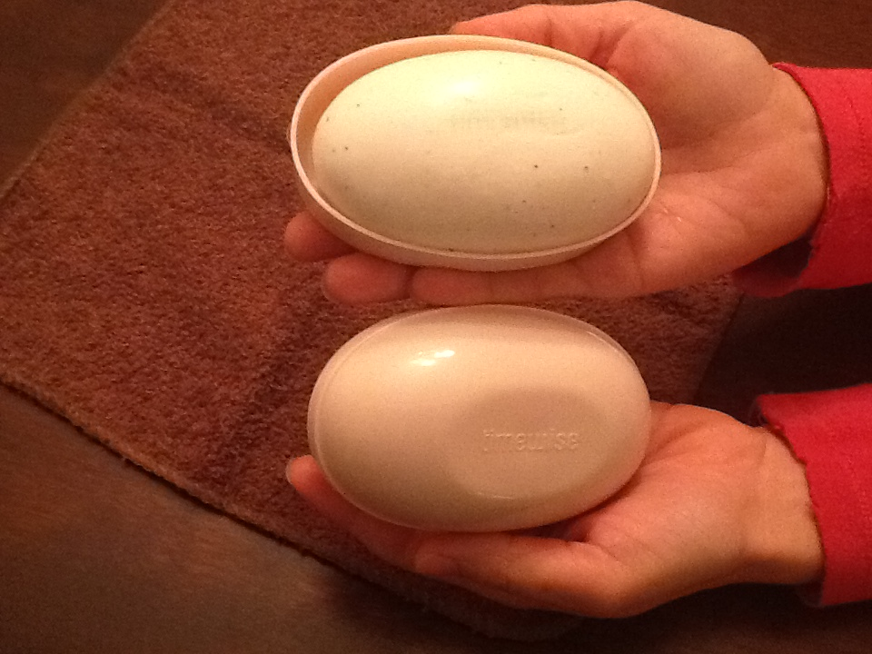

Place a Mary Kay® Timewise® 3 in 1 Cleansing bar in the middle of you wash cloth facing a corners then 2 corners grab and lift them to meet in the middle.

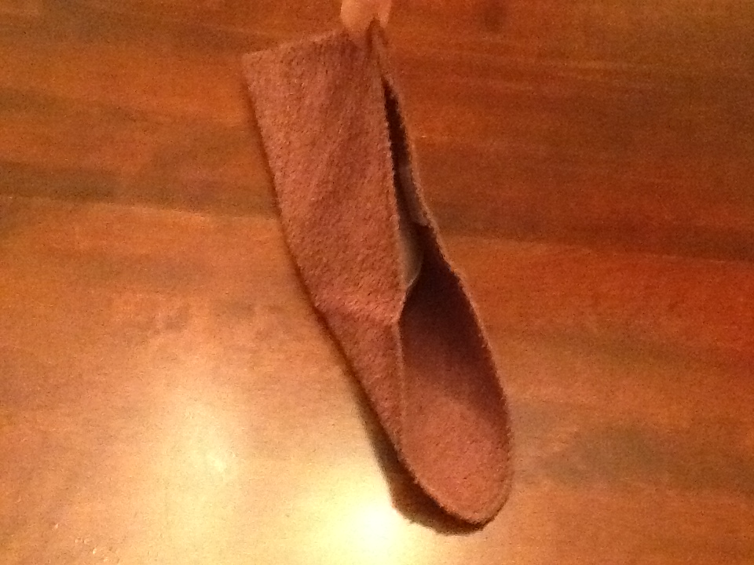

Take the 2 corners that you are holding in the air and roll them down. 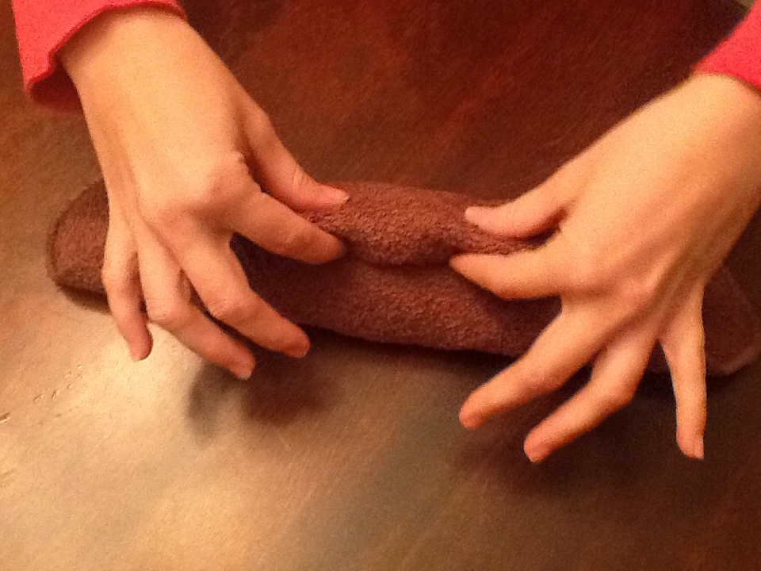

Hold that in place and take the last two corners that are laying flat and pull then up in the air (this will be your reindeer ears)

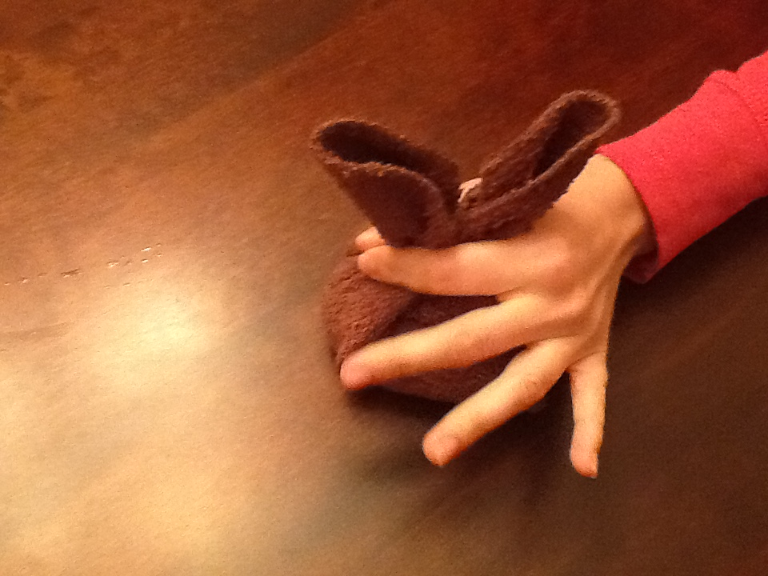

Secure this with a rubber band (I used a hair band I had handy)

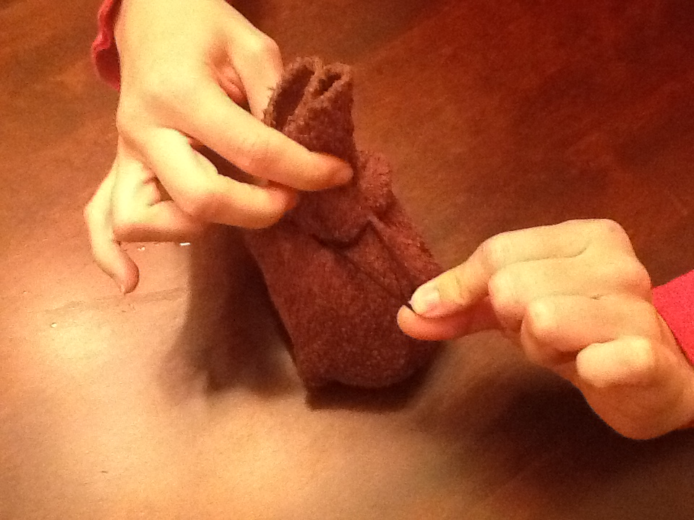

Ta Da! You now have the base of your reindeer, now it’s time to accessorize!

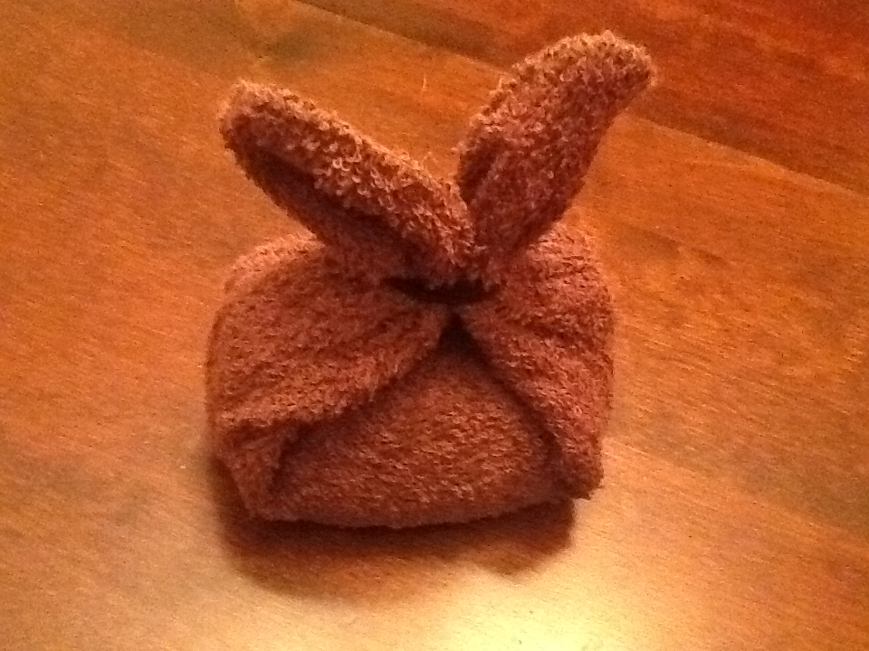

Take one of you full length pipe cleaners and bend (don’t cut) it in a “V shape and place it under your band

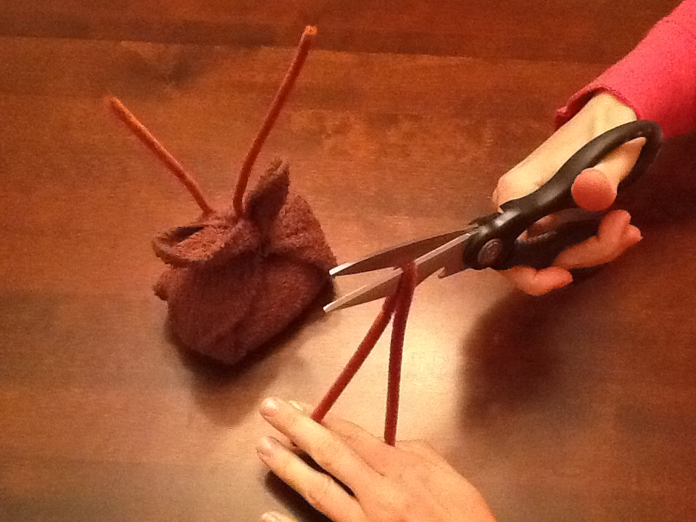

Take a second pipe cleanse and cut it in half

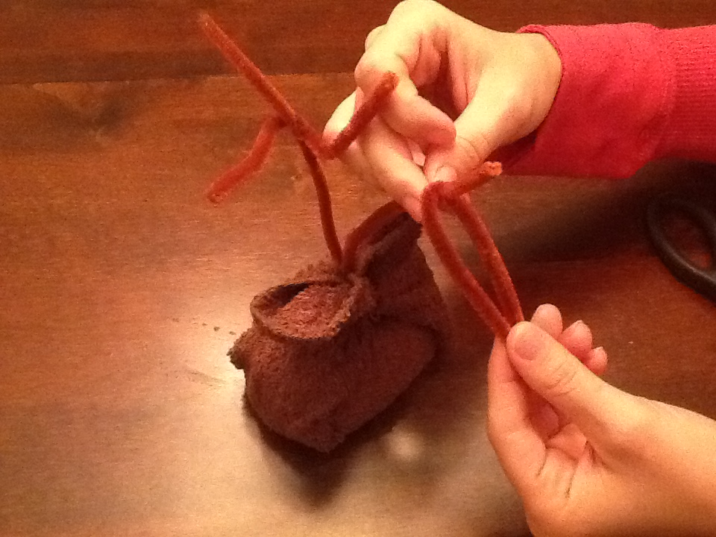

Wrap one of the halves of the pipe cleaner around the pipe cleaner that you have sticking up and make sure you wrap it tight (so it will not slide down). Now bend them to look like antlers.

Looking good now! It’s time to add your reindeer face; simply glue two eyes on. I have used a hot glue gun and I have also used eyelash glue when I was out of other glues and it worked great. Be creative if you need to.

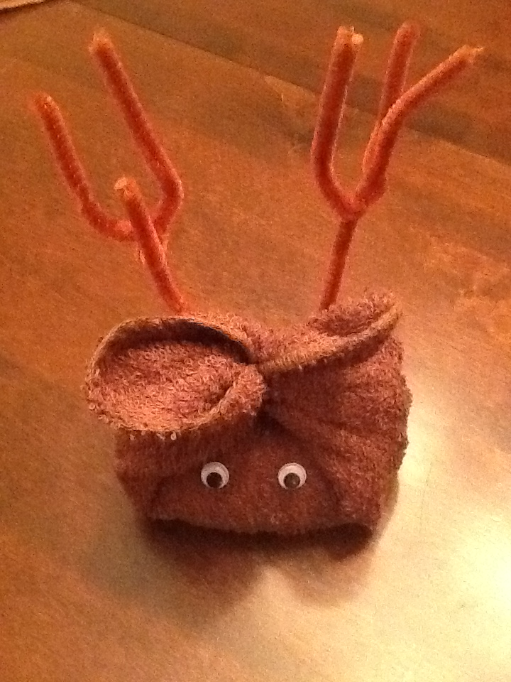

Now just glue your nose on. I love red but of course you could use black or any other color you like.

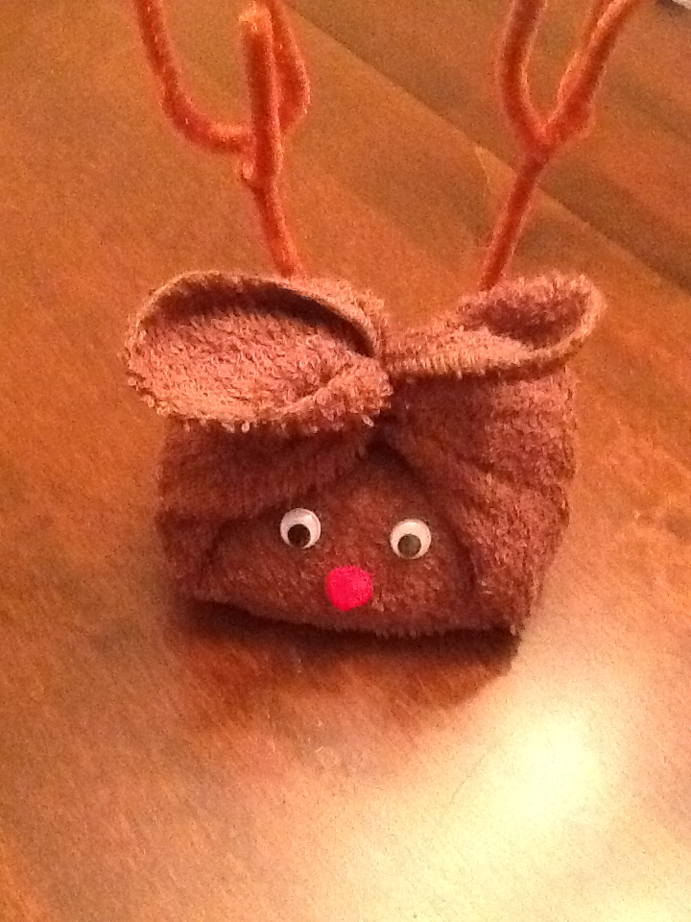

Now tie it up with a pretty bow to hide your rubber band and help support your antlers.

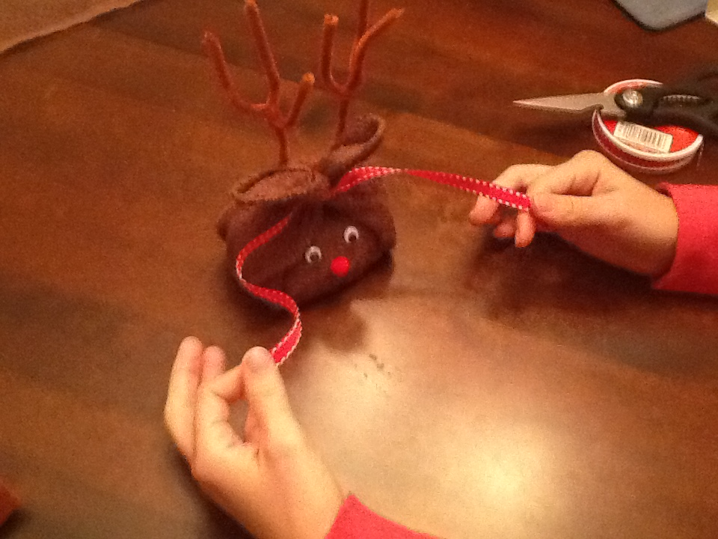

Your finished Product!

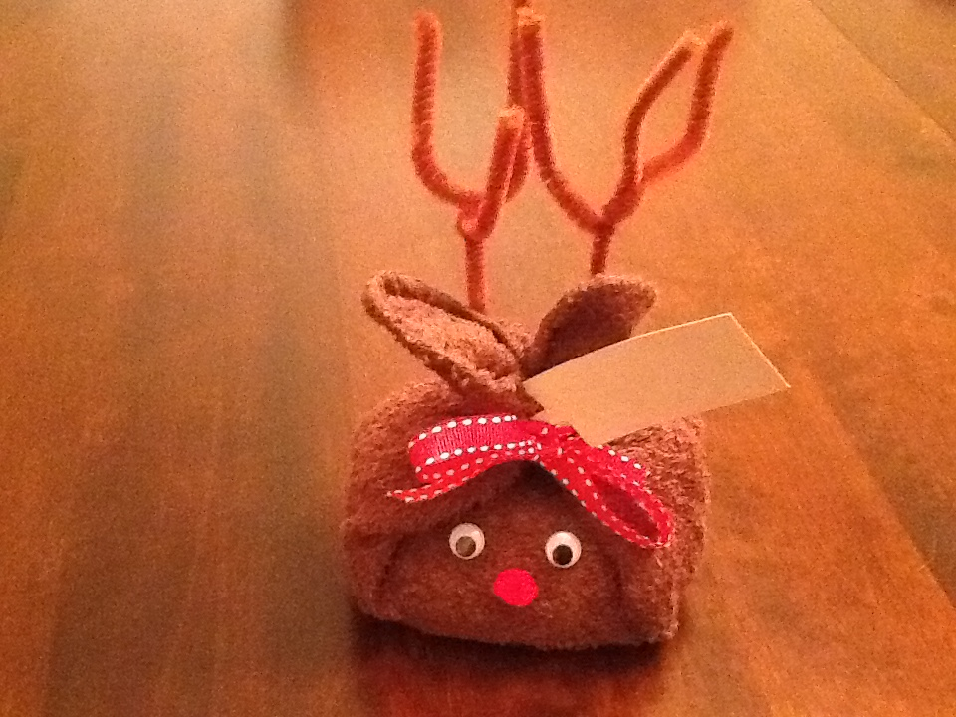

You can also use this same idea to wrap a small box instead of the Timewise® 3 in 1 Cleansing bar. This way you can fill the box with any small Mary Kay® item or items that your customer wants.

P.S. we tried this with a larger dishtowel and it did not look as good, mainly because it’s a large rectangle and not a square. Feel free to give it a try yourself; you may have better luck than we did.

Download a free Tag to go with your Reindeer!